Parent/Student Handbook
2020-2021
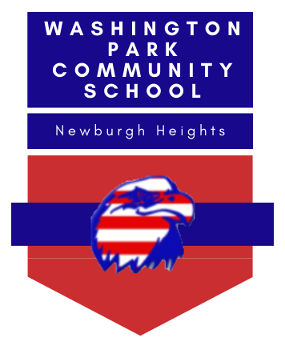

4000 Washington Park Blvd
Newburgh Heights, OH 44105
|p| 216-271-6055 |f| 216-271-6099
www.wpcsoh.org

Washington Park Community School
4000 Washington Park Blvd.
Newburgh Heights, OH 44105
Office Phone: 216-271-6055
Office Fax: 216-271-6099
Website: www.wpcsoh.org

Principal: Mrs. Cristy Madkins
Assistant Principal: Mrs. Melissa Cicerchi
Office Manager: Mrs. Katie Badford

TABLE OF CONTENTS
Introduction/Grading Scale | 2 | Internet Use Policy | 27-28
Admissions and Proof of Residency | 2-3 | Accident/ Injury/Illness | 28-42
Racial and Ethnic Balance | 4 | Child Abuse and Neglect | 43
Attendance/ Tardiness/Truancy and Intervention Strategies | 5-8 | Special Ed. Delivery Plan | 43-44
Withdrawal/Perfect Attendance/ Make Up Work/Emergency School Closing | 9 | Food Service | 45
Arrival/DismissalProcedures | 10-11 | Field Trips/ Non-Classroom Opportunities | 45-46
Releasing Students From School | 12 | Eighth Grade Shadowing | 46
Missing Child Policy | 12-13 | Hiring of Parents/Guardians/Relatives, Volunteering | 46-47
School and Personal Property | 13-14 | Public Meetings | 47
Dressing and Grooming | 14-16 | Board of Directors Contact Information | Attached
Student Code of Conduct / Student Discipline Procedures | 16-25 | Board of Directors’ Meeting Schedule | Attached
Student Investigations by Law Enforcement | 25-26 | WPCS Support Efforts | Attached
Anti-Bullying, Harassment and Intimidation Policy | 26-27 | Acknowledgement of Student/Parent Handbook | Attached
Playground Rules | 27

STUDENT/PARENT HANDBOOK

INTRODUCTION
Washington Park Community School is dedicated to preparing its students to become future leaders. In doing so, we will treat students with dignity, respect, care and discipline. The staff at Washington Park Community School is charged with the responsibility of maintaining a disciplined learning environment. They are given full responsibility to issue consequences to any student whose behavior is inappropriate. In order to protect the safety of Washington Park Community School students and to create the best possible learning environment, the students must follow the guidelines below:

GRADING SCALE

Kindergarten – Second Grade Third – Eighth Grade

P Proficient/at expected grade level A 100-90%
N Needs Improvement/seldom at grade level B 89-80%
U Unsatisfactory/significantly below grade level C 79-70%
expectations D 69-65%
F 64-0%

ADMISSION AND ENROLLMENT
Washington Park Community School adopts the following Policy regarding the admission and residency of students. The staff is directed to ensure that all forms and regulations are fully executed and conform to this Policy.

Washington Park Community School permits the enrollment of students who reside in any district in the State of Ohio. Admission to the School shall be open to any individual age 5 to 22 who is entitled to attend school under section 3313.64 or 3313.65 of the Ohio Revised Code in a school district in the state. Washington Park will not discriminate in the admission of students on the basis of race, religion, color, national origin, handicap, intellectual ability, athletic ability, or measurement of achievement or aptitude (unless at-risk limitations apply); will not exceed the capacity of our school’s programs, classes, grade levels, or facilities. Upon admission of any student with a disability, Washington Park will comply with all federal and state laws regarding the education of students with disabilities.

Preference shall be given to students attending Washington Park Community School the previous year and students who reside in the Cleveland Municipal City School District. Preference may also be given to siblings of students who attended in the previous year.

Children must be at least 5 years of age by August 1 of the academic year in which they desire to enroll in order to apply for admission to the school.

If the number of applicants exceeds the enrollment capacity for any grade level, a lottery will be held for those grade levels affected from all applications received prior to the initial application cut-off date, giving preference to students in the primary then secondary tier enrollment areas, in that order. The lottery, if required, will occur during the Board of Directors’ meeting during the month of April at the school, unless a different time and location is selected and publicized. Any person may be present during the lottery process, and all parents of children selected in the lottery will be notified of the selection by regular mail. Parents/guardians will have up to 7 days from receipt of the certified mail to inform the school if their child will attend the School. If a parent/guardian does not respond within 7 days of receipt of the certified mail, the parents of the first child on the waiting list established through the lottery will be advised that their child may enroll in the school.

Washington Park Community School requires students to produce documents verifying the students’ address and residence upon admission and once annually throughout the student’s enrollment in Washington Park. To provide acceptable proof of residency, parent/guardians must provide at least one of the following documents:
- A deed, mortgage, lease, current home owner’s or renter’s insurance declaration page, or current real property tax bill; Note: a rent receipt is not satisfactory proof of residency
- A utility bill or receipt of utility installation issued within 90 days of enrollment or annual verification;
- A paycheck or pay stub issued to the parent/guardian or student within 90 days of enrollment or annual verification that includes the parent/guardian’s or student’s primary residence;
- Any other official document issued to the parent/guardian or student that includes the parent/guardian or student’s primary residence.
These items must be current and include the parent/guardian’s name and a street address; a P.O. box address cannot be used to validate residency records. Any and all of the above information may also be required of any parents/guardians of students who are already enrolled, when in the judgment of responsible school officials, a question of residency remains. In compliance with state law, Washington Park will review residency records of enrolled students each month. At least once each school year, parents must again provide proof of current residency. Parents/guardians must also notify the School and provide appropriate verification when there is a change in the location of the parent’s/guardian’s or student’s primary residence while the student is enrolled in Washington Park Community School.

To register/enroll a student for school, a parent/guardian must bring the following information to the school:
- Birth certificate or document permitted to be accepted in lieu of a birth certificate under section 3313.672 of the Ohio Revised Code (such document must be provided upon registration/enrollment or within 90 days of the child’s initial entry into school);
- Health records listing up-to-date immunizations;
- Proof of Residency (see above);
- A certified copy of any court order, power of attorney, or affidavit designating parenting rights or identifying a residential parent; and
- Records given the student by the public or nonpublic school the student most recently attended, including the student’s IEP, if applicable.

RACIAL and ETHNIC BALANCE
Racial and Ethnic Balance- Washington Park Community School commits to a plan by which the school intends to achieve a racial and ethnic balance as defined in its enrollment practices.

Marketing Plan – In order to ensure a racial and ethnic balance in our school, Washington Park Community will disseminate announcements to the public through as many available routes as is practical, including (but not limited to):
- posting and distributing flyers in various communities and public venues
- attending community organizations’ meetings
- taking out advertisements in local newspaper(s)
- promotion on school’s website

These methods will help ensure that the invitation to hear directly about the opportunities offered to children is widely circulated. Washington Park Community School will collaborate with organizations to publicize events in the community through the local newspapers, Internet, and appropriate social media. Systematic efforts for outreach to area universities will also be conducted.

Washington Park Community School will use all the methods described above to help ensure that students of all races, languages, disabilities and abilities learn about the opportunities offered to children by our school.

Washington Park Community School does not discriminate against any student based on intellectual ability, measures of achievement or aptitude, athletic ability, disability, race, creed, national origin, religion, or on any other ground that would be unlawful.
All marketing materials will be available in English and other languages as needed.

ATTENDANCE
School Hours 8:00 a.m. - 2:50 p.m.
Breakfast Service 7:50 a.m. - 8:15 a.m.

The school day begins at 8:00 a.m. A student will be considered tardy if the student is not in the building by 8:00 a.m. Students are not permitted on school property until 7:50 a.m. For the safety of your child, please do not drop off your child until 7:50 a.m. Staff members are not available to supervise students until that time.

Students must attend school regularly in accordance with the laws of the State. The educational program offered by the school is founded upon the presence and punctuality of the student and requires continuity of instruction and student participation.

If a student is not able to attend school, the parent/guardian should telephone the school on the day of the absence by 8:15 a.m. A written notice from the parent/guardian or a physician indicating the cause of the absence will be sought by the school. If you would like to request your child's assignments for the extent of the absence please do so at the time the absence is reported. Every effort will be made to have the assigned work ready and in the office by 2:45 p.m. on the day of the request. Students should check with teachers upon return to school to review any missing work that remains.

HB 410 POLICY
A positive school climate requires students to: follow school rules; accept guidance from school staff; respect themselves and others; and be active citizens. The Board of Education has zero tolerance of violent, disruptive or inappropriate behavior by its students. Student conduct shall be governed by the rules and provisions of the Washington Park Community School’s Student Code of Conduct. This policy will be reviewed periodically. It is the responsibility of students, teachers and administrators to maintain a school environment that:
- Encourages all students to be actively engaged in their learning;
- Has consequences that are fair and developmentally appropriate;
- Relies on preventive and supportive interventions to support positive behavior and academic outcomes; and
- Fairly enforces the Washington Park Community School’s Student Code of Conduct.

All students and families are provided a copy of the Washington Park Community School’s Student Code of Conduct, which contains the rules and regulations that each student is expected to adhere to while in school or participating in any school-related activity, regardless of its location.
The district has developmentally and age-appropriate discipline strategies ranging from preventative approaches to supportive interventions to address student misbehavior, including excessive absences. Students who do not follow school rules on school property and/or at school-related events will be disciplined according to the terms set forth in the Board’s approved Washington Park Community School’s Parent/Student Handbook. The Washington Park Community School’s Student Code of Conduct provides students and families with examples of the types of behaviors that would subject a student to disciplinary action ranging from suspension or expulsion to other less severe forms. Suspension and expulsion will only be used once other options have been exhausted, unless the student’s behavior poses a threat to the safety of him/herself or others. A student may be subject to school disciplinary action, including suspension or expulsion for harassment, vandalism, physical abuse or other harmful or disruptive behavior toward school personnel or school personnel’s property during non-school hours. If a student’s suspension is longer than the school year, the student will not be required to complete the suspension at the beginning of the next school year. However, the student may be required to complete community service or an alternative strategy for engagement, per the superintendent, to be completed during the summer. Students may be subject to discipline for violation of the Washington Park Community School’s Student Code of Conduct, even if that conduct occurs on property not owned or controlled by the Board but that is connected to activities or incidents that have occurred on property owned or controlled by the Board, or conduct that, regardless of where it occurs, is directed at a Board and/or School official or employee or the property of such official or employee.
Regular school attendance is an important ingredient in students’ academic success. Excessive absences interfere with students’ progress in mastering knowledge and skills necessary to graduate from high school prepared for higher education and the workforce. To support academic success for all students, the district will partner with students and their families to identify and reduce barriers to regular school attendance. The district will utilize a continuum of strategies to reduce student absences including, but not limited to: Notifying the parent or guardian of a student’s absence; Developing and implementing an absence intervention plan on a case-by-case basis, which may include supportive services for students and families; Counseling; Parent education and parenting programs; Mediation; Intervention programs available through juvenile authorities; or Legal referral for truancy if applicable.
Ohio law requires that if a student is absent with or without legitimate excuse from school 38 or more hours in one school month, or 65 or more school hours in a school year, the following will occur. The school’s principal will notify the child's parent, guardian, or custodian of the child's absences after the date of the absence that triggered the notice requirement. If a student’s absences surpass the threshold for a habitual truant, the principal or chief administrator of the school or the superintendent of the school district shall assign the student to a district absence intervention team, which will develop an intervention plan for that student. Every effort will be made to include a parent, guardian or custodian as a member of the student’s absence intervention team. Notice of the plan developed by the student’s absence intervention team will be provided to the student’s parent, guardian or custodian. At no time, however, will students be expelled or suspended out of school due to excessive absences or for truancy. Applicable Ohio Revised Code Sections contained within this policy: ORC 3313.20 (Rules - locker search policy - professional meetings) ORC 3313.534 (Policy of zero tolerance for violent, disruptive or inappropriate behavior) ORC 3313.66 (Suspension, expulsion or permanent exclusion-removal from curricular or extracurricular activities) ORC 3313.661 (Policy regarding suspension, expulsion, removal, and permanent exclusion) ORC 3313.662 (Adjudication order permanently excluding pupil from public schools) ORC 3321.191 (Adoption of policy regarding student absences; intervention strategies).

Ohio Revised Code 3301-69-02 Regulations of excused absences from school:
For purposes of this paragraph, "approving authority" includes the person or office designated by the principal, superintendent, or local policy that in a given school reviews student absenteeism on a day-to-day basis and either approves or denies a student's reason for being absent from school.
(1) The parent or guardian must provide an explanation for the absence, which shall be recorded by the approving authority of the school and shall include the date and time of the absence. Emancipated youth and married children under the age of eighteen may provide the explanation for their absence from school to the approving authority;.
(2) An excuse for absence from school may be approved on the basis of one or more of the following conditions:
(a) Illness of the child. The approving authority may require the written statement of a physician/mental health professional if it is deemed appropriate;
(b) Illness in the family necessitating the presence of the child. The approving authority may require the written statement of a physician and an explanation as to why the child's absence was necessary, if it is deemed appropriate;
(c) Quarantine of the home. The absence of a child from school under this condition is limited to the length of quarantine as determined by the proper health officials;
(d) Death of a relative. The absence arising from this condition is limited to a period of eighteen school hours unless a reasonable causes may be shown by the applicant child for a longer absence;
(e) Medical or dental appointment. The approving authority may require the written statement of a physician or dentist if it's deemed appropriate;
(f) Observance of religious holidays. Any child shall be excused if his/her absence was for the purpose of observing a religious holiday consistent with his/her truly held religious beliefs;
(g) College visitation. The approving authority may require verification of the date and time of the visitation by the college, university, or technical college;
(h) Absences due to a student's placement in foster care or change in foster care placement or any court proceedings related to their foster care status;
(i) Absences due to a student being homeless; or
(j) Emergency or other set of circumstances in which the judgment of the superintendent of schools constitutes a good and sufficient cause for absence from school.

TARDINESS
A student who is tardy to school must report to the main office before going to class.
Unexcused reasons for absences and/or tardiness (based on Ohio attendance laws):
1. Car/transportation trouble
2. Oversleeping
3. Traffic jam
4. Staying out of school an unnecessary length of time because of appointments
5. Baby-sitting in non-emergency situations
6. Running non-emergency errands for parents or anyone else
7. Attending religious services when other non-school times are available.

TRUANCY and ABSENCE INTERVENTION STRATEGIES
The principal or his/her designee will act as the school’s attendance officer or delegate that duty as permitted by law. The school’s attendance officer shall investigate possible school attendance violations, and is authorized under Ohio law, to serve warrants, to enter places where children of compulsory school age are employed, and take such actions as necessary to enforce the compulsory education laws.

A student is excessively absent from school if a student is absent from school with or without legitimate excuse for thirty-eight (38) or more hours in one (1) school month or sixty-five (65) hours in one (1) school year. Within seven (7) days of a student becoming excessively absent from school, the principal shall notify the student’s parents of the student’s absences in writing.

A student is habitually truant if the student is absent without a legitimate excuse for thirty (30) or more consecutive hours, for forty-two (42) or more hours in one (1) school month, or seventy-two (72) hours or more in one school year.

Legitimate excuses for the absence of an otherwise habitually truant include but not limited to:
1. the student was enrolled in another school;
2. the student’s absence was excused in accordance with applicable law or
policy; or,
3. the student has received an age and schooling certificate.

If the student is habitually truant and the student’s parents have failed to cause the student’s attendance, the school will assign the student to an absence intervention team (AIT) within ten (10) days. The principal or designee selects the AIT members, who shall include a representative from the school who knows the child, the child and the child’s parent, guardian, custodian, guardian ad litem, or temporary custodian. Members may also include a school psychologist, counselor, social worker, or representative of a public or nonprofit agency designed to assist students and their families in reducing absences.

Within seven (7) days of the school determination that the student is habitually truant, the school will make at least three (3) reasonable, meaningful attempts to secure the child’s parent, guardian, or custodial parents participation on the AIT. If the parent responds to attempts but is unable to attend, the school will notify the parent of the right to participate by choosing a designee. In the event that the parent does not respond to the attempts at all, the school will investigate whether the failure to respond triggers child abuse and neglect reporting requirements and instruct the other members of the AIT to develop a plan for the child.

Within fourteen (14) days after its formation, the AIT will develop a written plan to reduce or eliminate student’s further absences. The AIT plan will state that a complaint will be filed in juvenile court alleging that the child is an unruly child not later than sixty-one (61) days after implementation if the child refuses to participate in or fails to make satisfactory progress on the plan or other alternatives to adjudication. The school will make reasonable attempts to provide the student’s parents with written notice of the plan within seven (7) days of development.

If a student becomes habitually truant during the last twenty-two (22) days of the school year, the School may assign one official to work with the parent and develop an AIT plan in lieu of forming a full AIT.

AIT Exemption: The School shall be exempt from AIT procedural requirements if it has a chronic absenteeism rate of less than 5% of the student body per the last state report card.

The school shall employ absence intervention strategies for all students who are excessively absent from School. Such strategies include the following, if applicable:

1. Providing a truancy intervention plan for any student who is excessively absent
from school;
2. Providing counseling for a habitual truant;
3. Requesting or requiring a parent to attend parental involvement programs;
4. Requesting or requiring a parent to attend truancy prevention mediation
programs.
5. Taking legal action under R.C. 2919.222, 3321.20, and/or 321.38.

If the 61st day falls during the summer months, at the school’s discretion, the absence intervention team or attendance officer may extend the implementation of the plan and delay filing the complaint for an additional thirty (30) or more consecutive hours or forty-two (42) or more hours in one school month, the attendance officer shall file a complaint with the juvenile court against the student, unless the absence intervention team has determined that the student has made substantial progress on the absence intervention plan.

The principal or his/her designee is also authorized to establish a parent education program for parents of students who are habitually truant. Any parent assigned to the program who does not complete the program is to be reported to law enforcement authorities for neglect of parent education, a fourth class misdemeanor if found guilty.

R.C. 2151.011, 2151.27, 3314.03(A)(6), 3321.01, 3321.041, 3321.13-.191

WITHDRAWAL

A student who fails to participate in one hundred five consecutive (105) hours of learning opportunities will be automatically withdrawn, unless the student’s absence is excused. Otherwise, a parent may withdraw a student voluntarily by signing a Voluntary Withdrawal form in the school office with the principal or his/her designee.

Whenever a student withdraws from the school voluntarily, the school shall attempt to ascertain the reason for withdrawal. If the student voluntarily withdrew from the school as a result of a change of residence, a copy of the student’s records will be mailed to the school, at the request of the student’s new school. The record will not be given to the family or to the student. Parents/Guardians must complete a release form prior to the records being forwarded to the new school.

If the principal or his/her designee becomes aware that a student who was withdrawn from the school for reasons other than a change of residence is not enrolled in another school, the principal shall notify the registrar of motor vehicles and the juvenile judge of the county in which the school is located of the student’s likely violation of the State’s compulsory education laws. Notice shall be given within two weeks and shall include the Student’s name, address, date of birth, and the district where the student resides. Any notice given in error shall be immediately rescinded by the principal or his/her designee.

ATTENDANCE DURING REMOTE LEARNING & COVID-19

Students will participate in synchronous (live) and asynchronous (independent learning) learning opportunities during the 2020-2021 school year due to COVID-19. Attendance will be taken daily. Teachers will track student attendance for each class during the school day. Students are required to attend the duration of each live class session to be considered in full attendance. Students completing independent work outside of live class sessions will also be required to submit completed assignments as evidence of class participation. Evidence of participation may include, but is not be limited to:
- Daily check-in surveys/questionnaires
- Daily interactions with the teacher to acknowledge attendance.
  - Examples of daily interactions between teachers and students could include, but are not limited to, messages, emails, telephone calls, video chats or other formats that enable teachers to engage with students.
- Assignment completion based on the number of hours expected for a typical student to complete.

Tracking Absences: Washington Park Community School will use the local student information systems to track attendance. The following options are used when tracking absences.
- Excused absences: Any circumstances for which an excuse is received—regardless of whether the particular time frame covered by the excuse is part of an in-school experience or a remote experience—should be recorded based on past practice. To the extent that remote learning creates new situations where granting an excused absence may be warranted, districts may need to establish new policies for excused absences based on existing options in Ohio Administrative Code 3301-69-02.
- No evidence of exposure, engagement or participation: If there is no evidence the student participated or engaged in any way in a remote learning activity, then the student should be marked with an absence for the hours for that remote learning activity.

MAKE UP WORK
When students are absent from school due to an excused absence, the student will meet with the teacher to review missed assignments. Students are expected to complete all assignments in the time period prescribed by the teacher.

EMERGENCY SCHOOL CLOSING
Information about a school closing (due to weather or an emergency) will be listed on the school's telephone system and listed on WKYC-TV3, WEWS- News channel 5, WJW-Fox 8. When the weather is threatening, please tune into these stations. If you do not hear or see Washington Park Community School included on the list of closed schools, then assume the school is open. Washington Park Community School is not associated with the Cleveland Municipal School District.

ARRIVAL & DISMISSAL PROCEDURES

MORNING ARRIVAL: 8:00 A.M. For the safety of your child, please do not drop off your child until 8:00 a.m., staff members are not available to supervise until that time.

DO NOT PARK OR STOP IN FRONT OF THE SCHOOL BUILDING – if you must park it has to be on the side streets or on the East 49th side of the Boulevard.

When dropping off your child in the morning, please enter the parking lot from McGregor Avenue only. Cones will designate a drop-off lane for you to follow. Please have your child follow the sidewalk to the front doors of the building. Although we will have adults assisting with this process, please stress to your child that he/she is not to cross the parking lot area and must stay on the sidewalks. Once the child has been dropped off, please proceed to exit on Alpha Avenue. Parking is not allowed in the lot area. This lot is used for staff parking only. In order to assure the safety of our students, the Newburgh Heights Police Department will be notified of those vehicles unauthorized to park in the lot during school hours.

We strongly encourage parents to allow their child to enter the building on their own. However, if a child must be escorted in, we ask that parents deliver their child to the designated room and then allow the classroom teacher to take charge. We are asking that you be considerate of the activities that are taking place in the rooms during this time as teachers are busy greeting students and preparing for the day. Staff will not be available for conferencing with parents during this time without a scheduled appointment to do so.

***For the duration of the 2020-2021 school year, parents and/or guardians are not permitted into the building during the school day due to COVID-19 safety protocols. Please see the COVID-19 section for further information.

For the safety of all of the students:
- DOGS ARE NOT ALLOWED on school property at any time
- SMOKING IS NOT PERMITTED on school property at any time

DISMISSAL

Students will be dismissed at 2:50 p.m. Kindergarten through Third Grade - Dismiss 2:50
- Walkers: dismiss out of the front doors and begin walking home.
- Bike Riders: dismiss out of the front doors and begin walking home.
- Car Riders: dismiss out of the side ramp doors when parent/guardian arrives.
  - Parents are to remain in his/her vehicle at all times and follow the flow of traffic.
  - Parents are not permitted to park and walk to the door to pickup his/her child(ren).
  - Do not honk your horn to signal your child(ren) to come to your vehicle, as we teach the students to wait until it’s properly time to enter the parking lot to the correct vehicle
  - Students will be directed to wait in an assigned area until directed to walk to parent/guardian’s vehicle.
- Parents/Guardians are not permitted to pick up other students without a verified note/phone call from the child’s parent/guardian.

Parking in the school parking lot is not permitted in an effort to maintain the safety of students. If there are special circumstances requiring parking lot accessibility parents/guardians need to speak with the principal to get necessary permissions to do so.

All students must exit the building by 3:00 p.m. If a child is not picked up by 3:00 p.m. they will be brought to the school office and parents will be contacted. Chronic issues with students being picked up on time from school will be addressed through conferencing with school administration. The school may also contact authorities if a student is not picked up from school by 3:00 p.m. if warranted.

WALKING PERMITS
Students who are permitted to walk to and from school must have a walking permit signed by a parent/guardian on file in the school office. There must be a signed walking permit for each individual student no matter how many siblings are in a family.

BICYCLE POLICY
All students in grades Kindergarten through Eighth grade are able to ride bicycles to school. Students who ride bicycles to school should dismount and walk bicycles across all crosswalks. All bicycle riders must wait and cross with the crossing guard. Bicycle riders must be courteous to walkers, one another, and follow directions of adults, and avoid strangers.

Students are not allowed to ride bikes on school sidewalks because of possible dangers to themselves and to others. Students must dismount and walk bicycles to the bicycle rack. Students must lock up bicycles and they must be placed neatly in the rack. Students must provide their own locks. Washington Park Community School and the Village of Newburgh Heights are not responsible for lost, damaged or stolen bicycles.

We are encouraging all students who ride bicycles to school to wear a helmet. This is for the protection of the student. Parents/guardians should review bicycle safety with students.

It is a privilege to ride a bicycle to school. Students who cannot follow the rules will are at risk of having their biking privileges taken away.

Any student who rides a bicycle to school must have permission from a parent or legal guardian and must have a permission slip on file in the school office completed by a parent or guardian. The school is not liable for any accidents or injuries that may occur to any child who is coming or going from school property. Scooters, skateboards, skate shoes, and rollerblades/in-line skates, etc. are not permitted.

RELEASING STUDENTS
If one parent has been awarded custody of a student by the courts, the parent with custody shall provide the school with a copy of the custody order and inform the school in writing of any limitations on the rights of the non-custodial parent. Without court documents, the school will presume the student may be released into the care of either parent.

No student will be released to anyone who is not authorized by the parent to receive the child. Parents must provide in writing to the principal the names of individuals to whom the school is authorized to release their children. The school must be provided this written list before it will release the child to anyone other than a recognized parent or guardian. Individuals picking up students from the school should be prepared to show identification.

Once students are on school grounds, they must remain until the end of the day. This includes the time students are waiting outside in the morning to enter the building. All students that leave the school building during school hours must be signed out by their parent/guardian in the school’s main office. If a student will be returning to school after his/her appointment a parent must accompany the student back in the building to sign the student in. A signed verification of appointment form, from the doctor/dentist, must be presented upon the student’s return to school. We encourage parents to make doctor, dentist, and etc. appointments after school hours.
MISSING CHILD POLICY/PROCEDURE
The Board of Directors of Washington Park Community School believes in the shared social responsibility of trying to decrease the number of missing children. Therefore, efforts will be made to identify possible missing children and notify the proper adults or agencies.

At the time of initial registration into school, the student’s parent/guardian shall present an official copy of the student’s birth certificate and copies of those records pertaining to
him/her which were maintained by the school which he/she most recently attended.

In lieu of a birth certificate, birth documentation may include: a passport; an attested transcript of the certificate of birth; an attested transcript of the certificate of baptism; an attested transcript of a hospital record showing the date and place of birth of the child; or a birth affidavit.

If the parent/guardian does not present copies of the required documents, the school administrator shall call the school from which the student transferred and request the information. If that district has no record on file of the student, or if that district does not send the records in 14 days, the administrator shall notify the appropriate law enforcement agency with the possibility that the student might be a missing child. The welfare of children in our care is paramount. Any report of a missing student, while attending Washington Park Community School, coming to the attention of school staff is considered very serious.

In the event of a missing student during school hours, the staff will follow the procedure listed below:

- Check restrooms, special areas and sign out sheets to make sure the student is not in the school building.

- Notify School Administration

- Notify parents/guardians immediately (check records to determine who has legal custody of missing child).

- Police should be notified by school administration immediately.

- When a student is missing collect following information and provide to police, parents/guardians:

  - When and where the student was last seen, what the student was wearing,
picture from student’s file, and who the student was with.

  - The names of any other people who might be able to provide significant
information (i.e. crossing guards, babysitter, neighbors).

  - The names of student’s close friends and whether those friends are at
school.

  - The student’s route and means of transportation to and from school.

  - Any people or vehicles around the school that was suspicious.

SCHOOL AND PERSONAL PROPERTY
Washington Park Community School teaches its students to respect property and develop pride in their school. Therefore each student is held responsible for the proper care of school property, supplies and equipment.

Parents or guardians will be notified of any damage to school property as a result of their child’s actions. Additionally they may be financially liable for the cost of damages. Fines will be imposed for the loss, damage or destruction of school equipment, apparatus, musical instruments, library materials, textbooks, as well as for damage to school buildings and/or grounds. Washington Park Community School reserves the right to withhold a report card, records or educational credits from any student who has not completely paid their (damage) fines.

Washington Park Community School may report to the appropriate juvenile authority any student whose damage of school property has been severe or chronic in nature.

PERSONAL PROPERTY
Students are not permitted to bring personal property or pets to school without permission from the teacher for a special project. Examples of personal property include: hand-held electronic games, electronic readers, any electronic device, cell phones, radios, headphones, toys, trading/collectable cards, etc. Items brought to school without permission will be confiscated by the office and held until a parent retrieves them.

STUDENT DRESS CODE AND GROOMING
Students at Washington Park Community School are expected to follow the standards for dress code outlined in the dress code policy. The guidelines were created to promote an appropriate and safe educational environment, while allowing students to dress appropriately, within limits, to facilitate learning. Our mission is education and we expect students to maintain the type of appearance that is not distracting to students, teachers, or the educational process of the school. Parents and children are equally responsible for the appearance of the child and will be notified in writing about changes that are made to the dress code. There is appropriate and inappropriate attire for all of life’s activities. The school administration may require students to change any clothing that is deemed inappropriate. For this purpose, the school administrators may ask the students’ parents to bring different clothing to the school for the student to change into. Keeping these ideas in mind, please help your child adhere to the guidelines as listed below.

The Administration reserves the right to determine if the student’s attire is inappropriate and/or unsafe regarding any items that may not be listed.

Dress/Grooming Category | Specifications:
Shirts  - Colors: Solid White, Navy Blue, or Light Blue  - Short or long-sleeved shirts with or without collars.  - Polo, button down, and t-shirt styles are all acceptable  - Solid White, Navy Blue, or Light Blue shirts may be worn under uniform tops | - No logos or print  - No sleeveless shirts, tank tops, “belly” shirts  - Shirts may not be oversized, bulky or have embellishments
Sweaters  - Colors: White, Navy Blue, Light Blue, Black  - May be solid color and/or patterned but must follow the color requirements listed above  - Cardigan or pullover  - Solid pullover sweatshirt allowed | - No logos or print  - No hoods and/or hoodies  - May not be oversized, bulky, or have embellishments
Pants, Shorts, Skirts, Skorts, Belts  - Colors: Solid Dark Blue, Black, or Khaki  - Belts - solid black or brown with no ornamentation  - Shorts and skirts must be mid thigh length or longer | - No denim jeans and/or  - No athletic pants, sweatpants, yoga, stretch pants  - Leggings may be worn under skirts only and must be dark blue, or black and no patterns
Shoes  - Tennis shoes and/or dress shoes are acceptable on all school days  - Socks must be worn  - Tennis shoes are required for participation in Physical Education | - No “Heelies,” work boots, hiking boots  - No platform shoes or heels higher than 1 inch  - No flip flops, sandals, backless, open-toed, or slides
Hair and headwear  - Neatly groomed  - Natural color  - Hats, hoods, scarves, bandanas and other similar articles must be removed upon entering the building. | - No unnatural colors including but not limited to: blue, red, green, orange, purple, burgundy  - No extreme hairstyles  - Facial hair is not permitted
Jewelry  - Piercing jewelry may be worn in earlobes only  - Must be reasonable size as to not pose a safety concern  - Students may wear one necklace, one bracelet, and/or one ring appropriate to learning environment | - No eyebrow, lip, nose, tongue piercings  - No piercing jewelry such as ring, hook, stud, spike, chain, spacers  - Bandages worn to cover piercings is not acceptable
Tattoos  - Students are not permitted to display tattoos whether temporary or permanent  - This includes henna, jeweled embellishments, and/or stickers | - If a student has a tattoo that would be visible it must be covered by bandage, sleeve, or other school appropriate method

DRESS CODE FOR PHYSICAL EDUCATION
Days that your child attends Physical Education (PE) class must wear rubber soled tennis shoes for participation. They may also wear plain, navy blue sweat pants, navy blue t-shirts and/or navy blue sweatshirts with no logo and must be size appropriate on gym days only.

DRESS CODE FOR DRESS DOWN DAYS
On occasion, the students of Washington Park Community School are allowed to dress down. Although the students are allowed to dress down their attire must still be appropriate for school. The school reserves the right to determine what is and what is not appropriate attire for school. Students are never allowed to wear flip flops, sandals, crocs and open-toed or slip on shoes, short shorts, mid-drift tops, low plunging necklines or shorts/pants with holes or tears in them. Parents/Guardians will be called and a change of clothes must be brought if an outfit is deemed inappropriate.

The Administration reserves the right to determine if a student’s attire is inappropriate. Any requested deviation from these requirements because of a bone fid religious or medical reason will be considered and resolved by the administration case-by-case.

STUDENT CODE OF CONDUCT

This conduct policy is issued under Ohio Revised Code Section 3313.661. Its goal is to assure a positive and safe school environment where the school's educational mission can be fulfilled.

This conduct policy applies while a student is on school property or at a school-sponsored activity. It also applies to a student's misconduct off school property that is connected to activities or incidents that occurred on school property. It also applies to a student's misconduct, regardless of where it occurs, that is directed at a school official or employee or the property of a school official or employee.

Any student engaging in a type of conduct listed below is subject to any of the following disciplinary actions, depending upon tier placement, the severity and frequency of the offense and all relevant surrounding circumstances. The actions include: warning, referral to office, after-school detention, in-school suspension, out-of-school suspension, or expulsion.

The types of conduct prohibited by this policy are:
- Damage, defacement, or destruction of school property, property of a school official or employee, property of another student, or any other private property on school premises.

- Fighting, instigating a fight, violence, horseplay.

- Hazing.

- Disregard of directives from teachers or other school authorities.

- Buying, selling, attempting to sell, using or possessing any tobacco or any lookalike tobacco product or tobacco paraphernalia, including, but not limited to, cigarettes, cigars, pipes, clove cigarettes, chewing tobacco, snuff, mint snuff, or tobacco in any other form.

- Buying, selling, attempting to sell, using, possessing or being under the influence of any controlled substance (marijuana, narcotics, etc.), inhalants, or any counterfeit or lookalike-controlled substance; buying, selling, attempting to sell, using, or possessing any drug paraphernalia.

- Buying, selling, attempting to sell, using, possessing or being under the influence of any prescription drug, medication, or inhalant which can be taken internally where the student does not have a legitimate health or other reason for the use or possession of such a substance.

- Buying, selling, attempting to sell, using, possessing or being under the influence of any alcoholic beverage or intoxicant.

- Conveying, attempting and/or threatening to convey, or possessing a firearm, explosive, incendiary device, fireworks, smoke bomb, poison gas, Mace, pepper spray, knife, dangerous ordnance or any other weapon.

- Unauthorized possession of a beeper, pager, cellular phone, other electronic communication device, or an electronic laser pointing or light-emitting device.

- Participation in gang activity or the display of gang-related symbols or messages.

- Cheating or plagiarism.

- Forgery of a school or school-related document.

- Gambling.

- Stealing

- Cursing and/or using indecent or obscene language (verbal and nonverbal).

- Publication, possession or observance of obscene or pornographic material

- Repeated tardiness.
- Leaving school premises during school hours without permission of the proper school authority.

- Violation of the school dress code policy.

- Disrespect or insubordination to a teacher or other school authority.
- Disruptive behavior in the classroom/school/school activities.

- Arson, attempted arson, playing with fire, or possession of lighters or matches.

- Assaulting, battering and/or inappropriately touching a teacher, other school official or employee, student, or any other person.

- Harassment of a school official or employee, student, or other person.

- Threats made towards a school official or employee, student or other person.

- Misbehavior that disrupts or interferes with any school or school-sponsored activity.

- Engaging in any sexual acts, indecent exposure, improper display of affection, or other inappropriate behavior which would include, but is not limited to touching or groping a person of the opposite or the same sex.

- Making a bomb threat or turning in a false fire, tornado, or other disaster alarm.

- Aiding another student or person to violate school rules or regulations.

- Commission of a crime or juvenile offense under Ohio's criminal or juvenile codes.

- Violating the school's acceptable use policy as to computers and the internet.

- Failing to report the known action or plan of another student or person to a teacher or school official where such action or plan, if carried out, would result in harm to another person or damage to property.

- Breaking and entering or being present in an area where the student has no legitimate business without permission of a proper school authority.

Except for serious offenses, the goal is to keep a student in school and teach the student that poor choices will lead to removal from school activities. For non-serious offenses, the necessary disciplinary steps will be taken. A student's misconduct, however, is always assessed case-by-case and deviations from the normal sequence may occur depending upon such factors as the nature and severity of the offense, the age and maturity of the student, the student's prior behavioral or disciplinary record, the student's demonstration of remorse and understanding of why the misconduct was unacceptable, etc. The proper authorities will be contacted in the case of serious offenses such as weapons, drugs, bullying etc.

STUDENT DISCIPLINE PROCEDURE
This policy is issued under Ohio Revised Code Sections 3313.66, 3313.661, and 3313.662 and paraphrases certain requirements and provisions from these statutes.

Should any such statute be amended in a way that is inconsistent with a term of this policy, the amended statute shall prevail.

The requirements of this policy do not apply to:

- a case of normal disciplinary procedures where a student is removed from a curricular activity for a period of less than one (1) school day and is not subject to an out-of-school suspension or expulsion;

- any in-school suspension where the student serves all of the suspension in a supervised learning environment school setting; or

- the emergency removal under Ohio Revised Code Section 3313.66(C) of a student by an administrator or teacher from a curricular activity or from school property where the student's presence poses a continuing danger to students or property or an ongoing threat of disrupting the academic process either within a classroom or elsewhere on school property (in such a removal the procedures appearing in Section 3313.66(C) will apply). The post-removal hearing will be held the next day. Students in grades K-3 who are emergency removed, will be readmitted the next day, and the school will forego the hearing, The school will not initiate suspension or expulsion for students in grades k-3 unless it is necessary to protect the immediate health and safety of the student or others of the student committed a serious offense.

Minor or technical deviations from the procedure outlined in this policy that are not prejudicial to the rights of the student will not taint the discipline of that student.

OUT-OF-SCHOOL SUSPENSIONS
A school Administrator may suspend a student from school for up to ten (10) school days. If fewer than ten (10) school days remain in the school year in which the misconduct occurs, the administrator may require the student to participate in a community service or alternative consequence during the first full week of summer break. In the event the student fails to complete the community service or assigned alternative consequence, the school district may determine the next course of action, providing it is not requiring the pupil to serve the remaining out-of-school suspension at the beginning of the next school year. Students shall be permitted to complete assignments missed during the suspension for 50% credit.

Prior to imposing a suspension, the student will receive written notice of the intent to suspend and be afforded an informal opportunity to appear before the Administrator (or Administrator's designee) to challenge the reason for the intended suspension or otherwise explain his/her actions.

EXPULSIONS / PERMANENT EXCLUSION
The appropriate school administrator may expel a student from school for a period not to exceed the greater of eighty (80) school days or the number of school days remaining in the semester in which the misconduct that gives rise to the expulsion takes place. If fewer than eighty (80) days remain in the school year in which the misconduct occurs, the administrator may apply any remaining part or all of the expulsion period to the following school year.

The Superintendent shall expel a student for a period of (1) one year for bringing a firearm onto school property or to a school-sponsored activity located off school property or at another school. In compliance with federal law, the school administration shall also refer any student expelled for possession of a firearm to the criminal justice or juvenile delinquency system. The administrator also may expel a student for a period of one (1) year for making a bomb threat to a school building or to any premises at which a school-sponsored activity is occurring at the time of the threat, for bringing a knife onto school property or to a school-sponsored activity located off school property or at another school, for possessing a firearm or knife initially brought onto school property by another person, or for committing an act that is a criminal offense when committed by an adult and that results in serious physical harm to persons or property as those terms are defined in Ohio Revised Code Sections 2901.01.

An expulsion under this paragraph may extend, as necessary, into the school year following the school year in which the misconduct that gives rise to the expulsion takes place. Any expulsion under this paragraph may be reduced on a case-by-case basis by the appropriate school administrator based on such factors as the age and maturity of the student, the degree of harm done, the candor and honesty of the student, the student's prior behavioral or disciplinary record, the degree to which the student exhibits remorse for the misconduct, or any other circumstance deemed relevant to the case. For purposes of this paragraph, "firearm" and "knife" have the meanings identified in the school's student code of conduct issued under Ohio Revised Code Section 3313.661.

Prior to an imposing expulsion, the Superintendent will give the student and the student's parent written notice of the intent to expel and afford the student and parent (and the student's representative, if any) an opportunity to appear before the administrator (or administrator’s designee) to challenge the reason for the intended expulsion or otherwise explain the student's actions.

Such notice will include:

- the reason(s) for the intended expulsion; and

- notification of an opportunity for the student, parent, and representative (if any) to appear before the administrator (or administrator’s designee) to challenge the intended expulsion or explain the student's action and the time and place to appear (which will be no earlier than three (3) not later than five (5) school days after such notice is given unless this time limit is extended at the request of the student, parent, or representative).

If the student withdraws from school after the misconduct that gives rise to the hearing but prior to the hearing itself or subsequent decision to impose an expulsion, expulsion proceedings will nevertheless proceed.

PROCEDURE FOLLOWING OUT-OF-SCHOOL SUSPENSIONS AND
EXPULSIONS
Within one (1) school day after a student's expulsion or suspension the administrator (or other school official who imposed the discipline in the case of a suspension) will notify the parent in writing of the expulsion or suspension. Such notice will include:

- the reasons for the expulsion or suspension

- notice of the right of the pupil or parent to appeal to the Board (or Board's designee), to be represented during such appeal, and to be heard against the expulsion or suspension;

- notice of the right to request that the appeal be heard in executive session; and

- if the expulsion is for more than 20 school days or if, regardless of its length, the expulsion extends into the following semester or school year, the notice will also provide the student and parent with information about services or programs offered by public and private agencies (including names, addresses, and phone numbers) that work toward improving those aspects of the student's attitudes and behavior that contributed to the incident giving rise to the expulsion;

- if the student is at least age 16, notice that the expulsion may be subject to an extension under Ohio Revised Code Section 3313.66(F) and that the Director may seek the student's permanent exclusion if the expulsion or suspension was based on an offense listed in Ohio Revised Code Section 3313.662 and the student is convicted of or adjudicated a delinquent child for that violation.

The student or parent may appeal the expulsion or suspension to the Board (or Board's designee) and be represented at such appeal. If requested by the student, parent, or representative (if any), the appeal will be heard in executive session. Any deliberations after the hearing may be held in executive session irrespective of the student's or parent's wishes. Action on the appeal must occur at a public meeting. The Board (by majority vote of its full membership)--or the Board's designee, if applicable--may affirm, reverse, vacate, or modify the expulsion or suspension. This decision may be appealed in accordance with Ohio Revised Code Chapter 2506. To perfect such an appeal, notice of the appeal must be filed with the Board and the Common Pleas Court of Cuyahoga County within 30 calendar days of the decision. The treasurer will be notified by the principal within one day of an expulsion.

Prior to the suspension of a student in grades k-3, the administrator must consider consulting with a mental health professional.

HONORING SUSPENSIONS OR EXPULSIONS FROM OTHER SCHOOLS
The appropriate school Administrator, after offering an opportunity for a hearing, may temporarily deny admission to any student currently suspended or expelled from another school until the expiration of that suspension or expulsion period. If such prior suspension or expulsion was from a school outside Ohio, such temporary denial will persist until the earlier of (A) the expiration of the suspension or expulsion period, or (B) the expiration of the period for which the student would have been suspended or expelled under the Washington Park Community School's student conduct policy had the student's out-of-state offense been committed here.

DISCIPLINE PROCEDURES FOR STUDENTS WITH DISABILITIES
Students with disabilities may be suspended for a period of up to ten (10) school days for a violation of the student code of conduct. Students and parents will be notified of the disciplinary action in a timely manner. Additional days of suspension or removal from school beyond ten (10) days may be assigned to students with disabilities if the school follows the procedures described in the book Ohio Model Policies and Procedures for the Education of Children with Disabilities and the New Ohio Operating Standards and Procedures (2008). This document is available in the office and will be made available to you to review upon request.

Suspension/ Expulsion of Disabled Students
In matters relating to the disciplining of disabled students, the Board shall abide by Federal and State laws regarding suspension and expulsion. The Principal, or designee, will follow the guidelines below and ensure they are properly used when disciplining any student with a disability.

Removals of Not More Than 10 Days- The 10-Day Rule
The School may unilaterally remove a student with a disability who violates a code of student conduct from the student's current placement for not more than 10 school days. This option may be used only if the disciplinary action is consistent with actions taken against non-disabled students. The School may place students removed under the 10-day rule in an appropriate interim alternative educational setting ("IAES") if applicable (see below), another setting, or suspend them. Removals under the 10-day rule are not considered a "change of placement" and the School is not obligated to provide services to students during those removals. The School can use the 10-day rule to remove a student for either a single removal of 10 consecutive school days; or a series of shorter-term removals over the course of the school year that are more than 10 consecutive school days during that school year, so long as those removals do not constitute a pattern of removals (and therefore, a change of placement).

Removals of More than 10 Days - Change of Placement
A change of placement occurs if a removal is for more than 10 consecutive school days; or if a student is subjected to a series of removals which accumulate to over 10 school days, that constitute a pattern. If a change of placement occurs (after a MDR (see below)), then the School must notify the parents or guardians of that decision. This notice must inform the parents or guardians of all the procedural safeguards accorded under the law. These safeguards include a manifestation determination review, a right to receive services, and a continuation of services for a free appropriate public education. The School must provide services that:
• enable the student to continue to participate in the general education curriculum (although
in another setting); and
• enable the student to progress toward meeting the goals set out in the student’s IEP.

Manifestation Determination Review (“MDR”)
The School will conduct a MDR to examine a student's behavior before imposing disciplinary consequences that would amount to a change of placement. The purpose of the MDR is to determine whether a student's disability caused, influenced or otherwise impacted the student's behavior in question. To make this determination, the student’s IEP team is required to review certain information and determine whether the behavior causing the disciplinary infraction is or is not a manifestation of the student's disability.

The MDR is not required for disciplinary removals that do not constitute a change of placement, that is, less than 10 school days per incident or a series of removals accumulating to more than 10 school days in one school year that do not constitute a pattern.

No later than the date on which the decision to take a disciplinary action which may be a change of placement is made, the School must notify the parents or guardians of that decision and of all procedural safeguards, including the MDR. The School and the parents or guardians must determine which members of the IEP team are relevant to conduct the manifestation determination. The team will review all relevant information in the student's file to determine whether the conduct in question was caused by, or had a direct and substantial relationship to, the student's disability or was the direct result of the School's failure to implement the IEP. If the team determines that either condition is applicable for the student, it must determine that the conduct is a manifestation of the student's disability.

Manifestation - If the team determines that the behavior was a manifestation of the student's disability, the full IEP team must meet the following requirements:
• conduct a functional behavior assessment and implement a behavior intervention plan for
the student, unless the School conducted a functional behavior assessment prior to the
manifestation determination;
• if the IEP team already developed a behavior intervention plan, it must review and modify
the plan as necessary to address the behavior; and
• return the student to the placement from which he or she was removed, 45-day rule
exception applies.

No Manifestation - If the team determines that the behavior was NOT a manifestation of the disability, the School may discipline the student using the relevant disciplinary procedures applicable to students without disabilities in the same manner and for the same duration, continuing to provide services to students with disabilities.

If a student's behavior was not a manifestation of the disability, the School will still take steps to attend to the student's behavior. The student must receive, as appropriate, a functional behavior assessment, behavioral intervention services and modifications designed to address the behavior violation in order to attempt to prevent a reoccurrence.

Exceptions to the MDR Requirement – The Unilateral Change in Placement and 45-Day Rule
School personnel may remove a student to an IAES for up to 45 school days, without a prior MDR or IEP meeting, when a student:
• carries or possesses a weapon (a device, instrument, material or substance, animate or
inanimate, that is used for, or is readily capable of causing death or serious bodily injury,
except that the term does not include a pocket knife with a blade of less than 2 1/2 inches in
length);
• knowingly possesses or uses illegal drugs (a controlled substance not legally possessed or
used under the supervision of a licensed healthcare professional, or legally possessed or
used under any other authority under the Controlled Substances Act (21 U.S.C. §812) or
under any other provision of federal law), or sells or solicits the sale of a controlled
substance (a drug or other substance identified under Schedule I, II, III, IV or V in the
Controlled Substances Act); or
• has inflicted serious bodily injury on another person (a cut, abrasion, bruise, burn or
disfigurement, physical pain, illness, impairment of the function of bodily member, organ or mental faculty, or any other injury, no matter how temporary).

This authority can be exercised if a student commits any of the offenses described above at the School, on the School premises or at a School function.

The IEP team will meet subsequent to the unilateral placement in an IAES, and must determine what the permanent setting will be, take steps to modify the student's IEP, as appropriate, provide appropriate behavioral intervention services and modifications designed to address the behavior violation so that it does not recur, and continue to provide the student with educational services to enable him or her to participate in the general education curriculum and to progress toward IEP goals.

The School must still do a MDR, but it can occur after the removal to the 45-day setting. If the conduct is a manifestation of the student's disability, the School must still meet all of the requirements outlined above for the MDR, with the additional exception that the student stay in the alternative placement for 45 school days, regardless of the outcome of the manifestation.

Due Process Complaint
Parents or guardians who disagree with any decision regarding placement or the outcome of an MDR may appeal the decision through the filing of a due process complaint. The School may request a hearing to change a student's placement if the School believes that maintaining the student's current placement is substantially likely to result in injury to the student or others. Under those circumstances, the hearing officer may order a change in placement of a student with a disability to an IAES for a period of up to 45 school days if the hearing officer agrees with the School’s assessment.

During any due process proceedings, the student’s placement, through a disciplinary action, must not change unless the parents/guardians and the School agree otherwise, or upon admissions to the School and parent/guardian consent. The School may change the student’s placement when taking disciplinary actions that constitute a change of placement against students with disabilities, or students who may be eligible for IDEA services.

In the case where a student has been placed in an IAES, the student will remain in the IAES chosen by the School, pending the hearing officer’s decision or until the time period expires, whichever occurs first, unless the parent and school agree otherwise. An expedited hearing will be arranged during an IAES appeal and will occur within 20 days of the hearing request, and the hearing officer must make a determination within 10 school days after the hearing.

Washington Park does not have a school resource officer, but if one is hired, the officer will follow all aspects of HB 318.

SEXUAL AND OTHER FORMS OF HARASSMENT
Washington Park Community School recognizes the right of students and employees to work in a pleasant environment free of harassment and discrimination. Therefore, Washington Park Community School strictly prohibits any student or employee from harassing another employee, student or visitor to the school with regards to religion, sex, race, color, disability or place of origin. Harassment includes but is not limited to verbal abuse, physical abuse, mental abuse, cyber-bullying, violence within a dating relationship and sexual harassment.

Any student or employee who believes he or she is a victim of harassment or has witnessed harassment should contact an administrator immediately. If a school administrator is the alleged source of harassment, the student or employee should inform a Board member.

Every effort will be made to conduct an investigation of the harassment as soon as practical after notification of the situation. Any student or employee involved in the
investigation is required to cooperate. A student or employee who has had harassment allegations brought against him or her may be suspended without pay while an investigation is being conducted.

A student or employee who has been found guilty of harassment charges against another employee, student or visitor to the school, will be disciplined and may be expelled (student) or terminated (employee).

PLAYGROUND RULES

No student leaves the playground without permission.

- SLIDE- Up the ladder. Down the slide sitting feet first. No climbing up the slide.

- BALLS- Only “Nerf” type allowed. Monitors will retrieve “out of bounds balls.”

- JUMP ROPES- For jumping only.

- NOT PERMITTED ON PLAYGROUND AT ANYTIME:

- Throwing of dirt, stones, mulch and snow

- Bad language

- Bullying

- Toys

- Eating or drinking

- No Tag on playground equipment or any other surface

- LINE UP IMMEDIATELY WHEN CALLED

INTERNET POLICY

Students at Washington Park Community School now have the ability to access the Internet in their classrooms. Although most of the internet is suited for viewing by children and young adults, there are several locations on the internet that are not. We will make every effort to ensure that your child does not view inappropriate material, however even with the filters and blocks, students might still be able to access inappropriate material. Classroom internet is for educational purposes only. Outlined below are the acceptable practices that all students and staff members must adhere to in order to use the internet here at Washington Park Community School.

All students that wish to use the internet will need to have a signed Student Agreement and Parent Permission Form for Electronic Information Access on file in the school office.

INTERNET MULTIMEDIA ACCEPTABLE GUIDELINES OF USE

Washington Park Community School offers student’s access to the Internet for educational purposes and preparation of the students for life and work in the 21st century. Students are expected to follow all guidelines; unacceptable use of the internet will result in termination of internet access, in whole or part, as well as other disciplinary or legal actions.

Acceptable uses of the Internet include participation in collaborative efforts, accessing real-time data and unique resources, publishing information and resources, and conducting research.

Unacceptable uses include, but are not limited to: accessing material that is profane or obscene; suggesting illegal acts and/or advocating violence or discrimination; using access to commit chain letters or personal contact information; participating in relayed
internet chats; news groups or mailing lists; granting access to unauthorized persons; intentionally failing to notify a teacher or administration when a student tries to access restricted information; agreeing to meet someone online; disruption of access to other users; causing damage or changing the standard operating function of the technology; use of obscene, vulgar, or threatening language; harassing others; posting defamatory
information; disregarding copyright laws of owners; causing or permitting protected material to be uploaded or broadcast in any way without written permission of the owner and school; posting items without adult or teacher consent; downloading large files; buying or selling any product or service; by-passing internet filters; using the internet without authorization of school personnel.
It is important to remember that the use of the internet is a privilege not a right. This privilege will be revoked if a student or staff member uses the internet in ways that are described under the unacceptable uses section. All users should be aware that the inappropriate use of electronic information resources can be a violation of local, state, and federal law and violations can lead to prosecution.

ACCIDENT/INJURY/ILLNESS PROCEDURES

Any injured student receives standard first aid from the staff member who is supervising the child. If a child receives an injury at school that is more serious than a minor cut, bump or nosebleed, the school’s first course of action, after providing first aid, will be to contact the parent. The parent’s instructions will be followed. If the parent/guardian cannot be reached by phone, the school will contact the next person listed on the child’s emergency medical form.

The Newburgh Heights Fire Department Rescue Squad will handle a child who is seriously injured. The school administrator will stay with the child during transportation to the nearest hospital. During a life-threatening situation, the rescue squad may be called prior to the parent.
Student Illness

The following guidelines have been approved by the Board of Directors to assist school staff when making decisions regarding sending a student home from school for health concerns.

- The Ohio Department of Health's Communicable Disease Chart must be posted in a convenient place in the school (clinic/office).

- Students are to be excluded from school for the following reasons:

  - Vomiting/diarrhea either in school and/or reported from home. Must have no vomiting/diarrhea within 24 hours of returning to school.

  - Temperature of 100º or higher in school or at home within the last 24 hours without anti-fever medication

  - Strep is suspected, but results of a throat culture has not been received

  - Positive throat culture for strep throat. Student may return to school after 24 hours of antibiotic treatment if the student’s condition is improved with no fever, fatigue, etc.

  - Symptoms of acute illness such as persistent cough, runny nose with body aches

  - Presence of lice/nits in hair

  - Pus-like drainage from the eyes

  - Severe headache, severe earache, severe or persistent abdominal pain

  - A rash suspected to be contagious

  - Wheezing/coughing episode in an asthmatic which is not relieved by prescribed medication

  - Injuries that require medical attention

  - Severe emotional concerns

It is the responsibility of the parent/guardian to make arrangements for child care in the event a child would develop signs of communicable disease or other illness/injury that prevent the child from functioning in class. Therefore, if a student is ill or injured and needs to leave school, the parent must make the necessary arrangements to provide care for their child outside the school setting. Students who are sent home with a fever, diarrhea, vomiting, etc. must remain symptom free for 24 hours before returning to school. Parents will be notified and students must be picked up if they return before the 24 hour mark. Students diagnosed with a contagious disease must remain out of school until a doctor writes a return to school note.

IMMUNIZATIONS
All students are required to have written proof on file that they have been immunized against Diphtheria, Tetanus, Pertussis, Poliomyelitis, Measles, Mumps, Rubella, Hepatitis B and Varicella (Chicken Pox) as set forth in Section 3313.671 of the Ohio Revised Code, unless specifically exempt for medical or other reasons. Students who have had the actual Chicken Pox disease are not required to have the vaccine, but we must have written proof from a physician. However, if there is a chicken pox epidemic in the school’s population, the administration may deny admission to a student otherwise exempted from the chicken pox immunization requirement. The administration shall prescribe methods whereby the academic standing of a student who is denied admission during a chicken pox epidemic is preserved.

One dose of Tdap or Td vaccine shall be required prior to entry into the 7th grade. This is intended to be a booster for all students who have completed the required doses of the initial series of DTaP/DT/Td vaccine. Students may not enter 7th grade without this vaccine.

Students who are not in compliance with all immunizations, no later than the fourteenth day after admission, will be excluded from school attendance.

PHYSICALS
A physical examination is strongly recommended for all new students to ensure that the student is able to take maximum advantage of the school’s educational opportunities.

The school office will provide a Health History form to be completed by a parent/guardian and a Physical Examination form to be completed by the student’s healthcare provider at the time of your child’s physical. Please return signed/completed forms to the school office as soon as possible.

MEDICATION
Many students require the use of medication in the treatment of disabilities or illnesses. When possible, administration of medication at home is strongly encouraged. When it is necessary for a student to take medication at school because no alternative is
possible, the following guidelines based on the Ohio Revised Code and the school district policy will be followed:

- A “Medication Request Form” must be completed for each prescription and over-the-counter medication and signed by the student’s physician/licensed prescriber and be delivered to the school office before medication will be administered to a student. This includes over-the-counter medications as well as prescription medications.
- Parent/guardian must sign the parent section of the request prior to medication administration.
- Parent/guardian shall agree to:
  - Deliver medication to school; no student shall carry medication in backpacks, pockets or in hand. An exception may be made for emergency medications that the physician has designated may be carried by the student (i.e. Asthma inhalers /Adrenalin.)
  - Notify the school if there is a change of prescribing physician.
  - Submit a revised request completed and signed by the physician who prescribed the medication if any information on the original request changes.
- Notes from parents/guardians will not be accepted in lieu of physician’s request
- New request forms must be submitted each school year and may be obtained in the school office.
- Medication must be received in the container in which it was dispensed by the pharmacist and labeled with:
  - Student’s name
  - Name of medication
  - Dosage and route of administration
  - Time of administration
  - Physician’s name
  - Pharmacy name and phone number
- Upon request, the pharmacist will divide medication into separate containers for home and school. Medication sent to school in any other container will not be administered.
- Over-the-counter medication must be in the original container and be clearly marked with the student’s name.
- Empty medication bottles will be sent home with the student and parent/guardian will be notified of the need for more medication. Parent/guardian will deliver replacement medication to the school office. Medication will not be accepted from students. All students are responsible for coming to the school office at the scheduled time to receive their medication.
- Medication will be administered by designated school personnel who have received Ohio Department of Health approved medication administration training from the school nurse.
- Medication will be administered according to the school medication procedure, which provides for safe administration and storage of all medications.
- A medication record will be kept on each student and will become part of the student’s confidential school health record.
- The school nurse will act as a consultant, and will be contacted when there are any questions about the medication, its administration or side effects. No medication will be administered at school if there are any unanswered questions.

SELF-ADMINISTRATION OF ASTHMA INHALERS
Ohio House Bill 121 allows children to carry their own inhalers for asthma rescue. This law was enacted to ensure the safety of students who experience asthma related distress during the school day. In the past, students were required to travel to the school office/clinic to obtain their inhaled medication when they experienced asthma symptoms. The school will not purchase inhalers for students to use.

If the following criteria are met, a student may carry and use their inhaler at school and school-related events:

- Permission from the student’s healthcare provider to carry and use the medication must be given to the school nurse/building administrator.

- The school nurse/building administrator must receive:

  - Name of medication
  - Dose
  - Start and end date
  - Indications for use of inhaler
  - Written instructions of what to do if the drug fails to reduce symptoms
  - Emergency phone numbers to contact the Physician and family
  - Adverse Reactions that can be expected if another student uses the inhaler

- According to this law the responsibility for asthma rescue is with the student.

- Students who are not able to assume this responsibility should not be allowed to carry their own medication. The asthma medication for these students should be managed and monitored by the school nurse or designated/trained staff.

- If a student will carry their own asthma inhaler, parents must educate and re-educate about the proper use of the inhaler including frequency and amount of medication. They should instruct their child to inform a responsible adult when they use their inhaler.

- A responsible adult should be aware when a student uses his/her inhaler. Frequent use of the inhaler may indicate a problem and should be reported to the parent/guardian, school nurse and building administrator.

- The school nurse will perform follow-up assessment to ensure the safety and proper administration of the inhaler by the student.

SELF-ADMINISTRATION OF EMERGENCY EPINEPHRINE
Ohio Revised Code 3313.718 allows children to carry their own Epi-Pen/Twinject for severe allergy exposure or symptoms. This law was enacted to ensure the safety of students who experience severe allergy related distress during the school day. In the past, students were required to travel to the school office/clinic to obtain their emergency injectable medication if exposed to an allergen or experiencing symptoms of life-threatening anaphylactic shock. The school will not purchase epinephrine to use with students.

A special request form is available in the school office if a child needs to carry this emergency medication.

Parents must communicate with and meet with the school nurse if their child has a severe allergy (usually to food or insect stings). An Emergency Healthcare plan will be developed to ensure the safety and well-being of the child.

3313.718 Possession and use of epinephrine auto injector to treat anaphylaxis.

(A) As used in this section, “prescriber” has the same meaning as in section 4729.01 of the Revised Code.

(B) Notwithstanding section 3313.713 of the Revised Code or any policy adopted under that section, a student of a school operated by a city, local, exempted village, or joint vocational school district or a student of a chartered nonpublic school may possess and use an epinephrine auto injector to treat anaphylaxis, if all of the following conditions are satisfied:

(1) The student has the written approval of the prescriber of the auto injector and, if the student is a minor, the written approval of the parent, guardian, or other person having care or charge of the student. The prescriber’s written approval shall include at least all of the following information:

(a) The student’s name and address;

(b) The names and dose of the medication contained in the auto injector;

(c) The date the administration of the medication is to begin;

(d) The date, if known, that the administration of the medication is to cease;

(e) Acknowledgment that the prescriber has determined that the student is capable of possessing and using the auto injector appropriately and has provided the student with training in the proper use of the auto injector;

(f) Circumstances in which the auto injector should be used;

(g) Written instructions that outline procedures school employees should follow in the event that the student is unable to administer the anaphylaxis medication or the medication does not produce the expected relief from the student’s anaphylaxis;

(h) Any severe adverse reactions that may occur to the child using the auto injector that should be reported to the prescriber;

(i) Any severe adverse reactions that may occur to another child, for whom the auto injector is not prescribed, should such a child receive a dose of the medication;

(j) At least one emergency telephone number for contacting the prescriber in an emergency;

(k) At least one emergency telephone number for contacting the parent, guardian, or other person having care or charge of the student in an emergency;

(l) Any other special instructions from the prescriber.

(2) The school principal and, if a school nurse is assigned to the student’s school building, the school nurse has received copies of the written approvals required by division (B) (1) of this section.

(3) The school principal or, if a school nurse is assigned to the student’s school building, the school nurse has received a backup dose of the anaphylaxis medication from the parent, guardian, or other person having care or charge of the student or, if the student is not a minor, from the student. If these conditions are satisfied, the student may possess and use the auto injector at school or at any activity, event, or program sponsored by or in which the student’s school is a participant.

(C) Whenever a student uses an auto injector at school or at any activity, event, or program sponsored by or in which the student’s school is a participant or whenever a school employee administers anaphylaxis medication to a student at such times, a school employee shall immediately request assistance from an emergency medical service provider.

(D)
(1) A school district, member of a school district board of education, or school district employee is not liable in damages in a civil action for injury, death, or loss to person or property allegedly arising from a district employee’s prohibiting a student from using an auto injector because of the employee’s good faith belief that the conditions of division (B) of this section had not been satisfied. A school district, member of a school district board of education, or school district employee is not liable in damages in a civil action for injury, death, or loss to person or property allegedly arising from a district employee’s permitting a student to use an auto injector because of the employee’s good faith belief that the conditions of division (B) of this section had been satisfied. Furthermore, when a school district is required by this section to permit a student to possess and use an auto injector because the conditions of division (B) of this section have been satisfied, the school district, any member of the school district board of education, or any school district employee is not liable in damages in a civil action for injury, death, or loss to person or property allegedly arising from the use of the auto injector by a student for whom it was not prescribed. This section does not eliminate, limit, or reduce any other immunity or defense that a school district,
member of a school district board of education, or school district employee may be entitled to under Chapter 2744. or any other provision of the Revised Code or under the common law of this state.

(2) A chartered nonpublic school or any officer, director, or employee of the school is not liable in damages in a civil action for injury, death, or loss to person or property allegedly arising from a school employee’s prohibiting a student from using an auto injector because of the employee’s good faith belief that the conditions of division (B) of this section had not been satisfied. A chartered nonpublic school or any officer, director, or employee of the school is not liable in damages in a civil action for injury, death, or loss to person or property allegedly arising from a school employee’s permitting a student to use an auto injector because of the employee’s good faith belief that the conditions of division (B) of this section had been satisfied. Furthermore, when a chartered nonpublic school is required by this section to permit a student to possess and use an auto injector because the conditions of division (B) of this section have been satisfied, the chartered nonpublic school or any officer, director, or employee of the school is not liable in damages in a civil action for injury, death, or loss to person or property allegedly arising from the use of the auto injector by a student for whom it was not prescribed.

BLOODBORNE PATHOGEN PROGRAM
Washington Park Community School is subject to Federal and State regulations to restrict the spread of Hepatitis B, C and HIV in the workplace. These regulations are designed to protect employees of the school who are, or could be exposed to blood or other contaminated bodily fluids while performing job duties.

We are committed to taking the necessary precautions to protect both students and staff.

One mandated procedure requires that the school to request the person who was bleeding at the time of an exposure gives consent to be tested for HBV, HCV and HIV. The law does not require parents/guardians to grant permission for the examination of their child’s blood, but it does require the school to request the consent. The parent/guardian must complete either a form to consent or refuse to consent for the blood tests.

The school must notify parents/guardians of this requirement in advance of any possible exposure. If an incident of exposure to blood does occur, the reason for the request is
already known. These are serious diseases and through proper precautions and cooperation, they can be prevented from spreading.

FOOD ALLERGY POLICY
Intent
Washington Park Community School is committed to the safety and health of all students and employees. In accordance with this and pursuant to Ohio Revised Code (ORC 3313.719), the purpose of this policy is to:

- Provide a safe and healthy learning environment for students with food allergies;

- Reduce the likelihood of severe or potentially life-threatening allergic reactions;

- Ensure a rapid and effective response in the case of a severe or potentially life-threatening allergic reaction; and

- Protect the rights of food allergic students to participate in all school activities.

Rationale
The prevalence of food allergies may be increasing, affecting as many as 8% of children nationwide. Food allergies result in about 30,000 emergency room visits and claim about 150 lives every year, with children and young adults being at greatest risk for having a fatal reaction. Nearly every school has students who have this severe, sometimes life-threatening condition, some of them undiagnosed. Schools are considered high risk areas for students with food allergies, with most incidents of accidental exposure occurring in schools. While schools may not be able to totally prevent allergic reactions, they can dramatically reduce both the likelihood of such reactions occurring and the severity of consequences if they do occur. Effective prevention and treatment plans, proper procedures, well-trained staff and clear communication can save lives.

The level of sensitivity and the types and severity of reactions vary considerably among individuals with food allergies. Therefore, the school’s approach to preventing and treating food allergies must be tailored to those individual’s needs. At the same time, an undiagnosed student may experience an allergic reaction to food for the first time while at
school and any allergic reaction can turn life-threatening. Therefore the school’s approach must also be comprehensive.

Definitions and Background Information
Anaphylaxis is an acute allergic reaction that affects more than one system of the body. It is a life-threatening event. If someone exhibits difficulty breathing, a drop in blood pressure, or symptoms in more than one body system (cutaneous, respiratory, gastrointestinal, or cardiovascular) after possible exposure to an allergen, it should be considered anaphylaxis. Medical attention and treatment should be sought immediately.

Emergency Health Care Plan (EHCP) means a set of procedural guidelines that provides specific directions about what to do in a particular emergency situation.

Epinephrine (also known as adrenaline) is the treatment of choice to prevent or treat anaphylaxis. It can help reverse the symptoms and prevent progression to other symptoms. It should be given immediately. A delay in treatment with epinephrine can be fatal.

Epinephrine auto-injector (sometimes called EpiPen) is a device that is used for the automatic injection of epinephrine into the human body.

Food allergy is an abnormal, adverse reaction to a food that is triggered by the body’s immune system. The immune system responds to an otherwise harmless food as if it was harmful, resulting in the release of various chemicals, including histamines. The most common food allergies are to peanuts, tree nuts, milk, soy, eggs, fish, crustacean shellfish, and wheat.

Food allergy symptoms are manifestations of the allergic reaction in various parts of the body. Symptoms may affect the:

- Cutaneous system (skin inflammation, tingling, itching, hives, rash, swelling of the lips, tongue and/or throat);

- Respiratory system (runny or stuffy nose, sneezing, coughing, wheezing, difficulty breathing);

- Gastrointestinal tract (abdominal cramps, vomiting, diarrhea); and

- Cardiovascular system (drop in blood pressure, dizziness, lightheadedness, heartbeat irregularities, fainting, shock).

Symptoms can begin immediately upon, or up to two hours after, exposure to an allergen. Some individuals exhibit initial symptoms followed by a second phase of symptoms two to four hours later. If more than one system is affected, it is considered anaphylaxis.

Individual Health Care Plan (IHP) means a comprehensive plan for the care of children with special health care needs, including food allergies. IHPs may include both preventive measures and treatment options.

Individual Health Care Plans and Emergency Health Care Plans
At Washington Park Community School, an Individual Health Care Plan and an Emergency Health Care Plan shall be developed for each student identified with any food allergy with potentially serious health consequences. The school nurse will develop the IHCP and EHCP in collaboration with the student’s health care provider, the parents/guardians of the student, and the student (when appropriate). This shall be done prior to entry into school or immediately thereafter for students previously diagnosed with an allergy; it should be done immediately at the diagnosis for students already enrolled who are newly diagnosed with an allergy. The plan should include both preventative measures to help avoid accidental exposure to allergens and emergency measures in case of exposure.
Depending on the nature and extent of the student’s allergy, the measures listed in the IHP may include, but are not limited to:

- Posting additional signs (e.g. in classroom entryways);

- Prohibiting the sale of particular food items in the school;

- Designating special tables in the cafeteria;
- Prohibiting particular food items from certain classrooms and/or the cafeteria;

- Completely prohibiting particular food items from the school or school grounds;

- Educating school personnel, students, and families about food allergies; and/or

- Implementing particular protocols around cleaning surfaces touched by food products, washing of hands after eating, etc.

These measures shall be taken in accordance with the Washington Park Community School health and wellness policy and food safety policy.
Plans shall also be developed for each staff member with a serious allergy.

School Protocol
At Washington Park Community School, the principal/school administrator, in coordination with the school nurse, shall implement a protocol, consistent with this policy and with the IHPs and EHCPs, providing food allergic students with protections while they are attending school or participating in school-sponsored activities. The protocols shall be reviewed and updated at least annually, as well as after any serious allergic reaction has occurred at school or at a school-sponsored activity.

Posting of Signs
At Washington Park Community School, signs shall be posted in a conspicuous place at every point of entry and within the cafeteria facility, advising that there are students with allergies to peanuts/tree-nuts. The exact wording on the sign may vary, in accordance with the measures contained within students’ IHPs and the school protocol.

Staff Training
At Washington Park Community School, the principal/school administrator shall identify school personnel who might be involved in managing an emergency in the school, including anaphylaxis. Training shall be provided for these personnel on the signs and symptoms of anaphylactic shock, proper epinephrine auto-injector administration, adverse reactions, accessing the “911” emergency medical system, and preparation for movement and transport of the student. At all times during normal school hours at on-site school-sponsored activities, at least one person other than the licensed school nurse must be trained and be responsible for the administration of the epinephrine auto-injector, subject to Good Samaritan provisions. These personnel shall review emergency protocols on an annual basis.

If trained school personnel are not available, any willing person may administer the epinephrine auto-injector. Good Samaritan provisions apply.

Communication
At Washington Park Community School, the principal/school administrator shall ensure that all school employees and other adults – including, but not limited to, school nurse, classroom teachers, specialty teachers, aides, student teachers, substitute teachers, food service staff, custodial staff, playground monitors– who may be involved in the care of a student diagnosed with a peanut/tree-nut allergy shall be informed of the IHP and the EHCP, as appropriate. These individuals should understand and consistently follow plans and protocols, be able to recognize symptoms of an allergic reaction, know what to do in an emergency, and work with other school staff to eliminate the use of food allergens in the allergic student’s snacks and meals, educational tools, arts and crafts projects, or incentives.

Parents/caregivers will be informed by the school about their rights and responsibilities regarding IHPs and EHCPs for food allergic students. They will be given clear guidance to help them follow the measures stipulated in these plans (e.g. avoiding peanut/tree-nut-based products in snacks or lunches).

The principal/school administrator shall work with the transportation providers for field trips to ensure that buses are equipped with required communication devices and that drivers are properly trained to recognize symptoms of allergic reactions and know what
to do in case of an emergency. A no eating policy should be enforced with appropriate exceptions made to accommodate diabetic students and others with special needs.

Self-Management
In Washington Park Community School, each student at risk for anaphylaxis shall be allowed to carry an epinephrine auto-injector with him/her at all times, if appropriate. If this is not appropriate, the epinephrine auto-injector shall be kept in a conspicuous place in the classroom, cafeteria, physical education facility, health room and/or other areas where it is most likely to be used, with reasonable safeguards in place to ensure its safekeeping. A medically identified student may self-administer the epinephrine auto-injector, if appropriate.

Emergency Protocols and Standing Orders
At Washington Park Community School, the school nurse shall prepare and update, as appropriate, but at least on an annual basis, written emergency protocols in the event of injuries and acute illnesses, including anaphylaxis. The Ohio Department of Public Safety’s “Emergency Guidelines for Schools” will be used as the school’s emergency protocols. The school nurse shall also review at least annually the procedures for addressing incidents of anaphylaxis and the use of the epinephrine auto-injector. Such procedures must include accessing the community’s emergency medical system (i.e.
“911”) and prompt transportation by a licensed ambulance/rescue service to an acute care hospital for medical evaluation and follow-up. Such procedures must also stipulate that the epinephrine auto-injector be used only upon the student for whom it was prescribed.

In the event of an episode of anaphylaxis, the principal/school administrator shall verbally notify the student’s parents/guardians as soon as possible or delegate someone to notify them. Following the episode, the school nurse shall complete a written report and file it in the student health record.

Allergy Bullying
All threats or harassment of students with food allergies will be taken very seriously and will be dealt with in accordance with the Washington Park Community School bullying policy and pursuant to Ohio Revised Code, Section 3313.666

Evaluation and Review
This policy shall be reviewed and updated on a regular basis, particularly after a serious allergic reaction has occurred at a school or at a school-sponsored activity.

Confidentiality
Pursuant to Section 504 of the Rehabilitation Act of 1973 (Section 504), the Family Educational Rights and Privacy Act (FERPA), the Health Insurance Portability and Accountability Act of 1996 (HIPAA) and other statutes and regulations, the confidentiality of students with food allergies shall be maintained, to the extent appropriate and as requested by the student’s parents/caregivers.

Legal Reference
Ohio Revised Code Sec. 3313.719
Americans with Disabilities Act (ADA)
Individuals with Disabilities Education Improvement Act of 2004 (IDEA),
Section 504 of the Rehabilitation Act of 1973 (Section 504),
Family Educational Rights and Privacy Act (FERPA),
Health Insurance Portability and Accountability Act of 1996 (HIPAA)

HANDWASHING POLICY
It is well known that frequent and adequate hand washing will reduce the transmission of communicable disease. In light of this fact, Washington Park Community School has implemented the following building-wide hand washing policy. This policy is based upon the recommendations of the Ohio Department of Health.
Hand washing shall be required to occur after:

- Using the toilet

- Cleaning toilets and bathrooms

- Handling animals

- Cleaning up after vomiting or fecal accident

- Cleaning and sanitizing environmental surfaces

- Eating and drinking

Hands should also be washed before:

- Preparing or handling food

- Eating food

Hand washing facilities shall be maintained in good repair and will be properly supplied to encourage hand washing by students and staff as recommended in the Ohio Department of Health’s school inspection guide manual:
- Hot and cold water shall be available at all rest rooms
- Soap and paper towels shall be available at all sinks
- Sinks will be properly supplied with cleaning supplies
- Hand washing posters shall be visibly posted by all sinks
- Hand sanitizer shall be available in classrooms.

In order to reduce absenteeism from communicable diseases staff will:

- Teach students proper hand washing techniques annually with frequent reinforcement.

- Teach students about how germs are spread

- Encourage students to wash their hands

- Encourage students to use hand sanitizer when hand washing is not possible and to wash hands as soon as possible after coughing, sneezing, blowing nose.

- Clean and sanitize classroom environmental surfaces on a daily basis.

- Clean and sanitize door knobs, handrails and water fountains on a daily basis (custodial/cleaning)

HEAD LICE POLICY
The State of Ohio affords the right for school districts to implement policies that protect the general health and welfare of the student population as well as our staff. Therefore, the Board of Directors of Washington Park Community School has adopted the following Head Lice Policy:

Once it is determined that the student has contracted head lice, the parent/guardian will be notified and must come in to pick up their child. The child must have proper treatment, be nit free and pass a head inspection by a school staff member or school nurse before they are readmitted to school. A parent/guardian must accompany the student on
their return to school in order to assure that the student passed the head inspection and is going to be readmitted to school.

A student’s attendance should be minimally affected (the day of exclusion and possibly one more day) if treatment is done immediately according to recommended procedures.

SUICIDE PREVENTION POLICY
The Washington Park Community School in recognition of the need to protect the health, safety and welfare of its students, to promote healthy development, to safeguard against the threat or attempt of suicide among school aged youth, and to address barriers to learning, hereby adopts this policy. This policy corresponds with and supports other federal, state and local efforts to provide youth with prevention education, early identification and intervention, and access to all local resources to promote health and prevent personal harm or injury. Students who are in need of intervention will be referred to the administration.

All staff members are responsible for safeguarding the health and safety of all students. All staff members are expected to exercise sound professional judgment, err on the side of caution and demonstrate extreme sensitivity throughout any crisis situation. All school personnel should be informed of the signs of youth depression/suicide. Any staff member who is originally made aware of any threat or witnesses any attempt towards self-harm, that is written, drawn, spoken or threatened, will immediately notify the Director of Education or their designee. Any threat in any form must be treated as real and dealt with immediately. No student should be left alone, nor confidences promised. Thus, in cases of life threatening situations a student’s confidentiality will be waived. Our district’s suicide crisis response procedures will be implemented. The entire policy may be viewed in the main school office.
Definitions:

*Suicidal Crisis- A situation where suicidal ideation and/or behavior occurs.

*Suicidal Gesture- An act of bodily harm or intended bodily harm with the expressed intent of suicide.

*Suicidal Ideation- (Specific) Thoughts and feelings which, when expressed, communicate a plan for self-harm resulting in death.

*Suicidal Ideation- (Non-specific) Thoughts and feelings which communicate no specific plan but do express a desire to harm self resulting in death.

Parents will be contacted regarding the crisis and a course of action will be discussed. It will include obtaining an evaluation for the student from a qualified mental health professional within 24 hours, in order to ensure the safety of the student.

Document must be presented to the school or a phone call from the mental health provider to the appropriate school Administrator.

Outside agencies such as Mobile Crisis Intervention, Children’s Services or the Newburgh Heights Police or Fire Departments will become involved in the crisis when necessary.

CHILD ABUSE AND NEGLECT
School employees are mandated reporters of known or suspected child abuse and neglect. Therefore, all staff members will receive required training and must follow Ohio Revised Code regulations and the school’s procedure regarding the reporting of child abuse and neglect. Mandated reporters must report both known and suspected child abuse and/or neglect to Children’s Services or the police department.

SPECIAL EDUCATION SERVICE DELIVERY PLAN
General Education with Consultation.
The student is served in the general education classroom without any accommodations or modifications to the curriculum, instruction, testing or grading. The service provider is responsible for consulting with general education teacher and monitoring the student’s progress according to the IEP.

General Education with Consultation/Accommodations.
The student is served in the general education classroom with consultation and support from the special education teacher. The general education teacher is responsible for direct instruction, testing, grading and behavioral management as specified in the IEP. The special education teacher support may include assisting the general education teacher with the design and preparation of materials, adaptations and accommodations. The special education teacher is responsible for monitoring the student’s progress on IEP goals.

General Education with direct special education support in the general education classroom.
The student receives special education support for the general education curriculum in the general education setting. The special education teacher, support service provider, or trained paraprofessional will be in the general education classroom to provide direct instruction, instructional support, or other assistance to the student or a group of students, through models such as collaborative or co-teaching. The special education teacher/service provider is responsible for monitoring the student’s progress on IEP goals.

General Education with direct special education support outside the general education classroom.
The student receives special education support for the general education curriculum outside the general education setting. When the services cannot be appropriately provided in the general education setting, the student may receive selected services or all services he/she needs in a separate educational setting (including, but not limited to special classes, special schools, home instruction and instruction in hospitals and institutions). The special education teacher/service provider is responsible for monitoring the student’s progress and IEP goals.
Notes:
- Students may receive different services at multiple points based on the IEP.
- The district will provide access for all eligible individuals based on their IEP. Services may be provided within the school, or through contractual agreement with other districts and/or agencies.
- A student/special education teacher ratio of 14:1 will be maintained at all times.

VISITORS AND CLASSROOM VISITS
For the safety of our students and staff, it is important for us to be able to identify all visitors to our building. All visitors must sign in at the main office prior to going to the classroom or lunchroom. They will be given an identification badge to wear for the duration of the visit and must be returned to the main office upon signing out. In order to minimize unexpected interruptions to the learning environment we ask that parent visits are pre-arranged and scheduled with the classroom teacher.

PARENT-TEACHER CONFERENCES
Parent teacher conferences will be held twice during the school year, once in the Fall and once in the Spring. Parents will receive an appointment prior to the conference dates. Parents/Guardians may contact teachers and administrators anytime throughout the year to schedule a conference when necessary.

CLASSROOM PARTIES
In line with the vision of the school and in order to maximize student learning and time on task, classroom parties will be at the discretion of the classroom teacher/administrator.

If a parent or guardian would like to celebrate a child’s birthday, he or she may send a wrapped treat (in-line with the school wellness policy) to school for each class member. The treats will be distributed at the end of the school day. Please consider bringing a healthy, low sugar snack.

VIEWING STUDENT RECORDS
In compliance with all provisions of State and Federal law, parents may view their child’s school records. Please call the school’s office to arrange an appointment.

FOOD SERVICE
Washington Park Community School participates in the National School Lunch Program
under the Community Eligibility Provision (CEP). This allows us to provide free breakfast and lunch to all students.

Students are also allowed the option of bringing a packed lunch with them to school.
Per the school wellness policy, students are not allowed to bring pop, coffee or energy drinks to school.
NON-CLASSROOM BASED LEARNING
It is recognized that students at Washington Park Community School are not bound by their classroom for learning experiences. On occasion, our students participate in learning enhanced field trips. Students also have tutoring experiences when deemed appropriate. While suspension/expulsion is not a common occurrence with our students, if a student is suspended out-of-school, they will be provided with internet or independent study. Assignments are provided. The school has purchased various internet-based programs which students can access any place where the internet is available. The Cleveland Municipal Library visits the school to guarantee each student who wants one is given a library card.

No child may attend a classroom field trip/school sponsored event without completion of a Field Trip Form filled out and signed from a parent/guardian. Verbal permission either in person or over the phone will not be accepted. Field Trip Forms are available in the main office.
The school will provide transportation to and from the field trip. Students must remain with the class for the duration of the field trip which includes travel time. No students will be transported in staff and/or parent/guardian vehicles.

HIGH SCHOOL SHADOWING FOR EIGHTH GRADERS
Any Eighth grader who wishes to shadow at a high school must obtain prior consent and a form from the school office. A day of shadowing is considered an excused absence. Parents/guardians must follow the absence guidelines by calling into the office of the day of the absence and submitting a note. Parents/guardians assume all responsibility for transportation to and from the high school on the day of the visit. Students are expected to adhere to the behavior and dress code policies of the school they are visiting.

VOLUNTEERING IN THE SCHOOL
Washington Park Community School appreciates volunteers in school activities. However, the school may require a background check of volunteers at any time. This also pertains to any visitor or guest at the school who interacts with students in an unsupervised manner.

PARTICIPATION IN PUBLIC MEETINGS
Parents or guests of the Board of Directors meetings will be given an opportunity to speak during Open Session (20 minutes) or they may submit a question or issue in writing to the President of the Board of Directors. The question or issue must be written and submitted to the President of the Board of Directors at least one week prior to a regularly scheduled Board meeting. Board Meetings are conducted every other month on the first Thursday of that month. A schedule of Board Meetings is posted in the front lobby.

COVID-19 Protocols
A Reopening Guide for Families & Staff 2020-2021
Dear Washington Park Community School Families and Students,

On behalf of the Washington Park Community School, I would like to thank you for your patience and support during these difficult months. The following pages contain information regarding the learning and instruction for the 2020-2021 school year. The onset of COVID-19 has impacted our country, the state of Ohio, and our community in Newburgh Heights. The impact of the pandemic has transformed the direction and importance of making decisions regarding education. Our primary goal is to keep everyone safe and healthy, and to stop the spread of COVID-19. As school reopens, this goal is at the forefront of our decisions and will be implemented into our daily practice.

Our staff members return to work on August 13th to begin preparing for the school year. Students’ first day of school will be on August 17th. We recognize that instruction cannot be further delayed. Our students deserve the opportunity to receive instruction, while the school continues to ensure all policies and protocols are in place. All students will participate in online learning for a few days to start the year and be sure everyone has working hardware to access our platform if needed. Further details regarding online learning expectations are provided later in this plan.

It’s important to note that this learning plan is fluid and may change at any time. As we saw in the spring of 2019, the switch to learning in the school, to learning online could happen at any time. All families, students, and teachers need to be equipped and prepared for online learning in the event the school must close. The school will follow the Cuyahoga County Health Department, the CDED, and orders from Governor DeWine.

In the event that Cuyahoga County is reported a Level 4 Emergency, the school building will close, and learning will switch to online for everyone. The school will use the level indicators to discover local trends and community spread. More information about county identifications and public emergencies can be found here. Most believe that COVID-19 isn’t going away anytime soon. Education must be adjusted and not put on hold as we navigate through this. Washington Park Community School will be providing 2 options to all of our students. Every family and home environment is different, which is why parents and guardians must select the learning option that is most appropriate for their child(ren).
Learning Options:
Option 1 | Students come to learn in person at the building daily with safety protocols in place.
Option 2 | Students are at home daily, learning online, with a WPCS licensed teacher. Students receive live lessons from their teacher daily.
Parents and guardians must select their learning option no later than August 7th. The following pages are to help parents and guardians make an informed decision on what is best for their child’s learning platform. We thank you for the opportunity to educate your children. As life for all of us has transformed during the pandemic, education must also. I’m proud of the support each of you share to help promote education for your children. We are in this together and will come out even stronger!

Stay Safe and Stay Healthy,
Cristy Madkins; Principal
216-271-6055

Important Dates:

- Friday, August 7: Parents/guardians must select their learning choice by completing the Learning Option Form

- Thursday, August 13: Staff first day. All staff are to report to the building by 8:00 a.m.

- Friday, August 14: Parents/guardians will pick up student learning materials from the school at the designated times.

- Monday, August 17: Students’ First Day of School (online)

- Students opting in Option 1 (in school learning) will report to the building on, Thursday, August 20

Learning Options General Overview:
Families will have two (2) options for selecting an appropriate learning environment for their child(ren). This page offers general information, or an overview. A specific plan of each option is provided later in this plan.

Option 1: Attend School in Person
- Walk or get dropped off at school daily
- Safety protocols will be in place (hand-washing, sanitizing, minimal movement throughout the building, daily health and temperature screenings)
- School provides face coverings and face shields for all students and staff
- Social distancing protocols will be in place in all areas including: classrooms, hallways, restrooms, parking lot, and recess areas. Students and staff’s work areas will include the use of plexiglass for additional protection
- Walk or get picked up from school daily at the scheduled time

Option 2: Learn from Home
- Students enroll in online learning for one semester (quarters 1 & 2)
- Online classes are taught by WPCS teachers
- Students will log on at scheduled times and participate with the students who are on-site in live instruction and interaction. Students will also have independent learning opportunities that relate to the live lessons
- Curriculum follows Ohio Department of Education guidelines
- Students will be provided with a laptop and additional resources to achieve learning goals
- Students choosing to learn from home must have internet access (the school may offer hotspots for internet access to families in need)

In both options, students will be expected to participate in all local and state testing as required by the Ohio Department of Education. Attendance requirements following HB 410 and the Ohio Department of Education will apply. Students with an IEP or 504 plan will receive accommodations and may be provided additional and/or alternate coursework that will align to the student’s plan. All students will have access to free breakfast and lunch options provided by the school. In addition, all school supplies and learning materials will be provided by the school.

Option 1: Attending School in Person:

When choosing to send your child(ren) to school, multiple layers of protection will be in place to help the virus from spreading. In order to keep all Washington Park Community School students and staff safe, the use of physical and social distancing, face masks, other PPE, and increased hand-washing guidelines will be implemented within the school building.

- All policies, practices, and procedures will follow mandates and guidelines created by the Ohio Department of Health, the Ohio Department of Education, the Cuyahoga County Department of Health, Cleveland Department of Health, and orders from Governor DeWine.
- Learning schedules and building start/end times, will not be adjusted or changed during the semester
- Students will begin online classes on August 17th to adjust to computer and other technology skills
- Students will report to the school building for in-person instruction on: Thursday, August 23rd
- Specific guidelines will be in place for students and staff moving throughout the building to follow social distancing and to minimize contact. This includes a one-way entrance and exit to the building, supervised trips to the restroom, nurse, cafeteria, and office.
- There will be limited travel throughout the school, and students will be closely monitored
- The drinking fountains will be off limits. The school will provide water to students from water coolers that an adult will bring to the classroom twice per day.
- There will be no more than 2 students and a staff member at one time in the restrooms.
- Parents and visitors will not be permitted to enter the school building unless it is an emergency
- Any parent/guardian will not be permitted to pick their child up early from school without an important need. (example- doctor appointment, etc.)
- Classroom furniture will be spaced appropriately, and will face in the same direction
- There will be no large gatherings (assemblies, field trips, breakfast/lunch in the cafeteria)
- In order to minimize germ spread on common areas, all classroom doors will remain open
- Students will eat in their classrooms
- Shared materials (glue sticks, pencils, crayons, etc.) will be off limits. The school will provide students individual bags of essential supplies to support the learning process
- Any item that is used by more than one person (computers or books) will be sanitized following each use.
- Students will have one assigned seat in the classroom for all purposes.
- Students & staff will not be permitted to share food and snacks with classmates and colleagues. This includes birthday treats, potluck lunches, and class prizes that contain food.
- All meetings will be held virtually or by following social distancing guidelines.
- Additional cleaning and disinfecting procedures will take place before, during, and after school hours. This includes the use of an electrostatic sanitizer that will help eliminate harmful viruses in the air and on surfaces.
- Recess for all K-8 students will be outdoors, weather permitting, and at staggered times maintaining distancing. There will be limited activities and the playground will be off limits.
- Hand sanitizer will be available in every learning and non-learning spaces. Additional hand sanitizer will be placed in high traffic areas such as the hallway, and by entrances and exits.
- Additional opportunities for handwashing will be implemented throughout the day
- The school will monitor student and staff absences daily. Our school nurse, Mr. Marsh, will provide communication between administration, staff, and families as needed.
- Anyone coming into the building must wear an appropriate face mask (see face mask policy for more details)
Classroom Example of Physical Distancing:
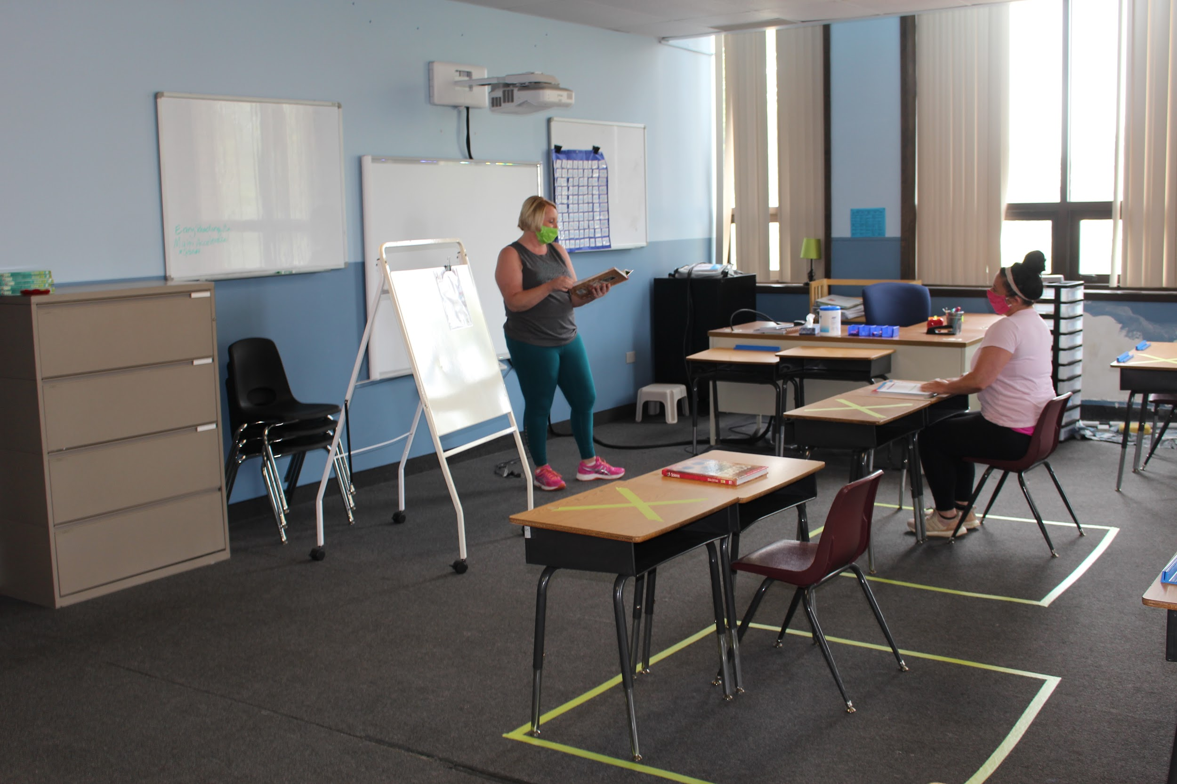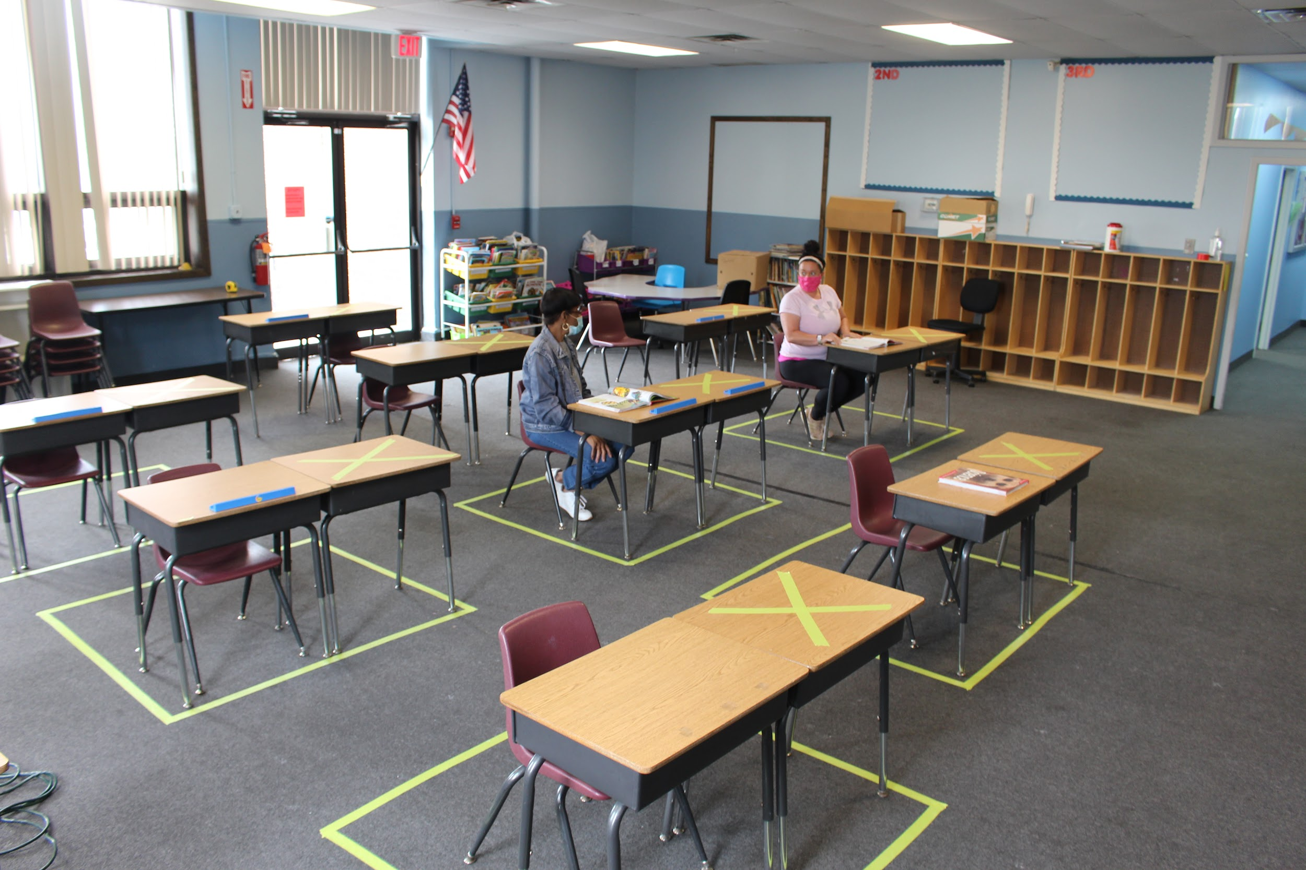
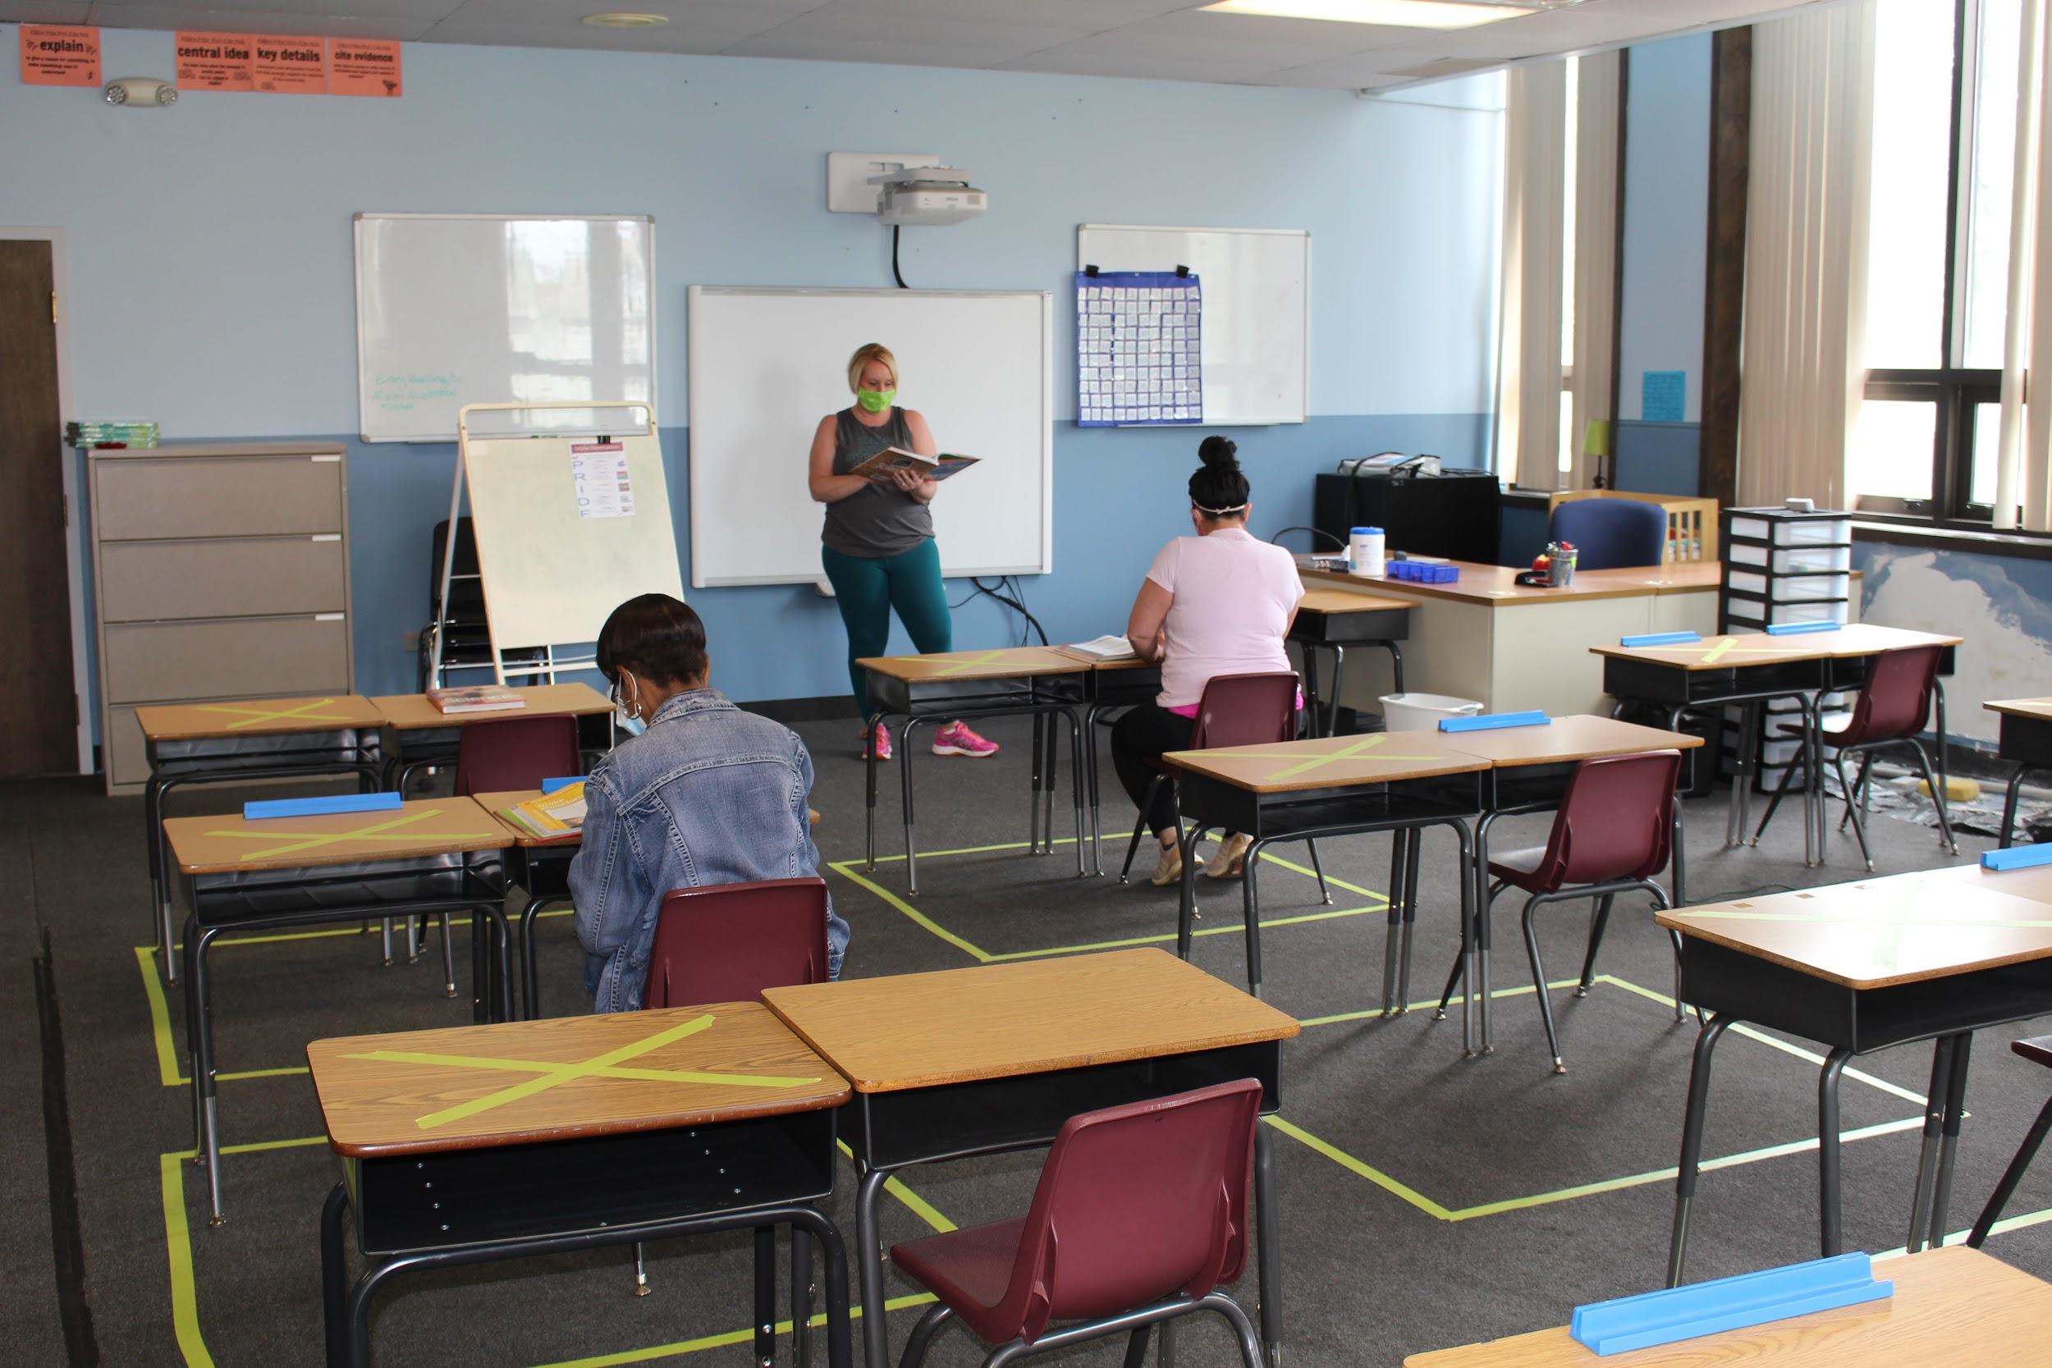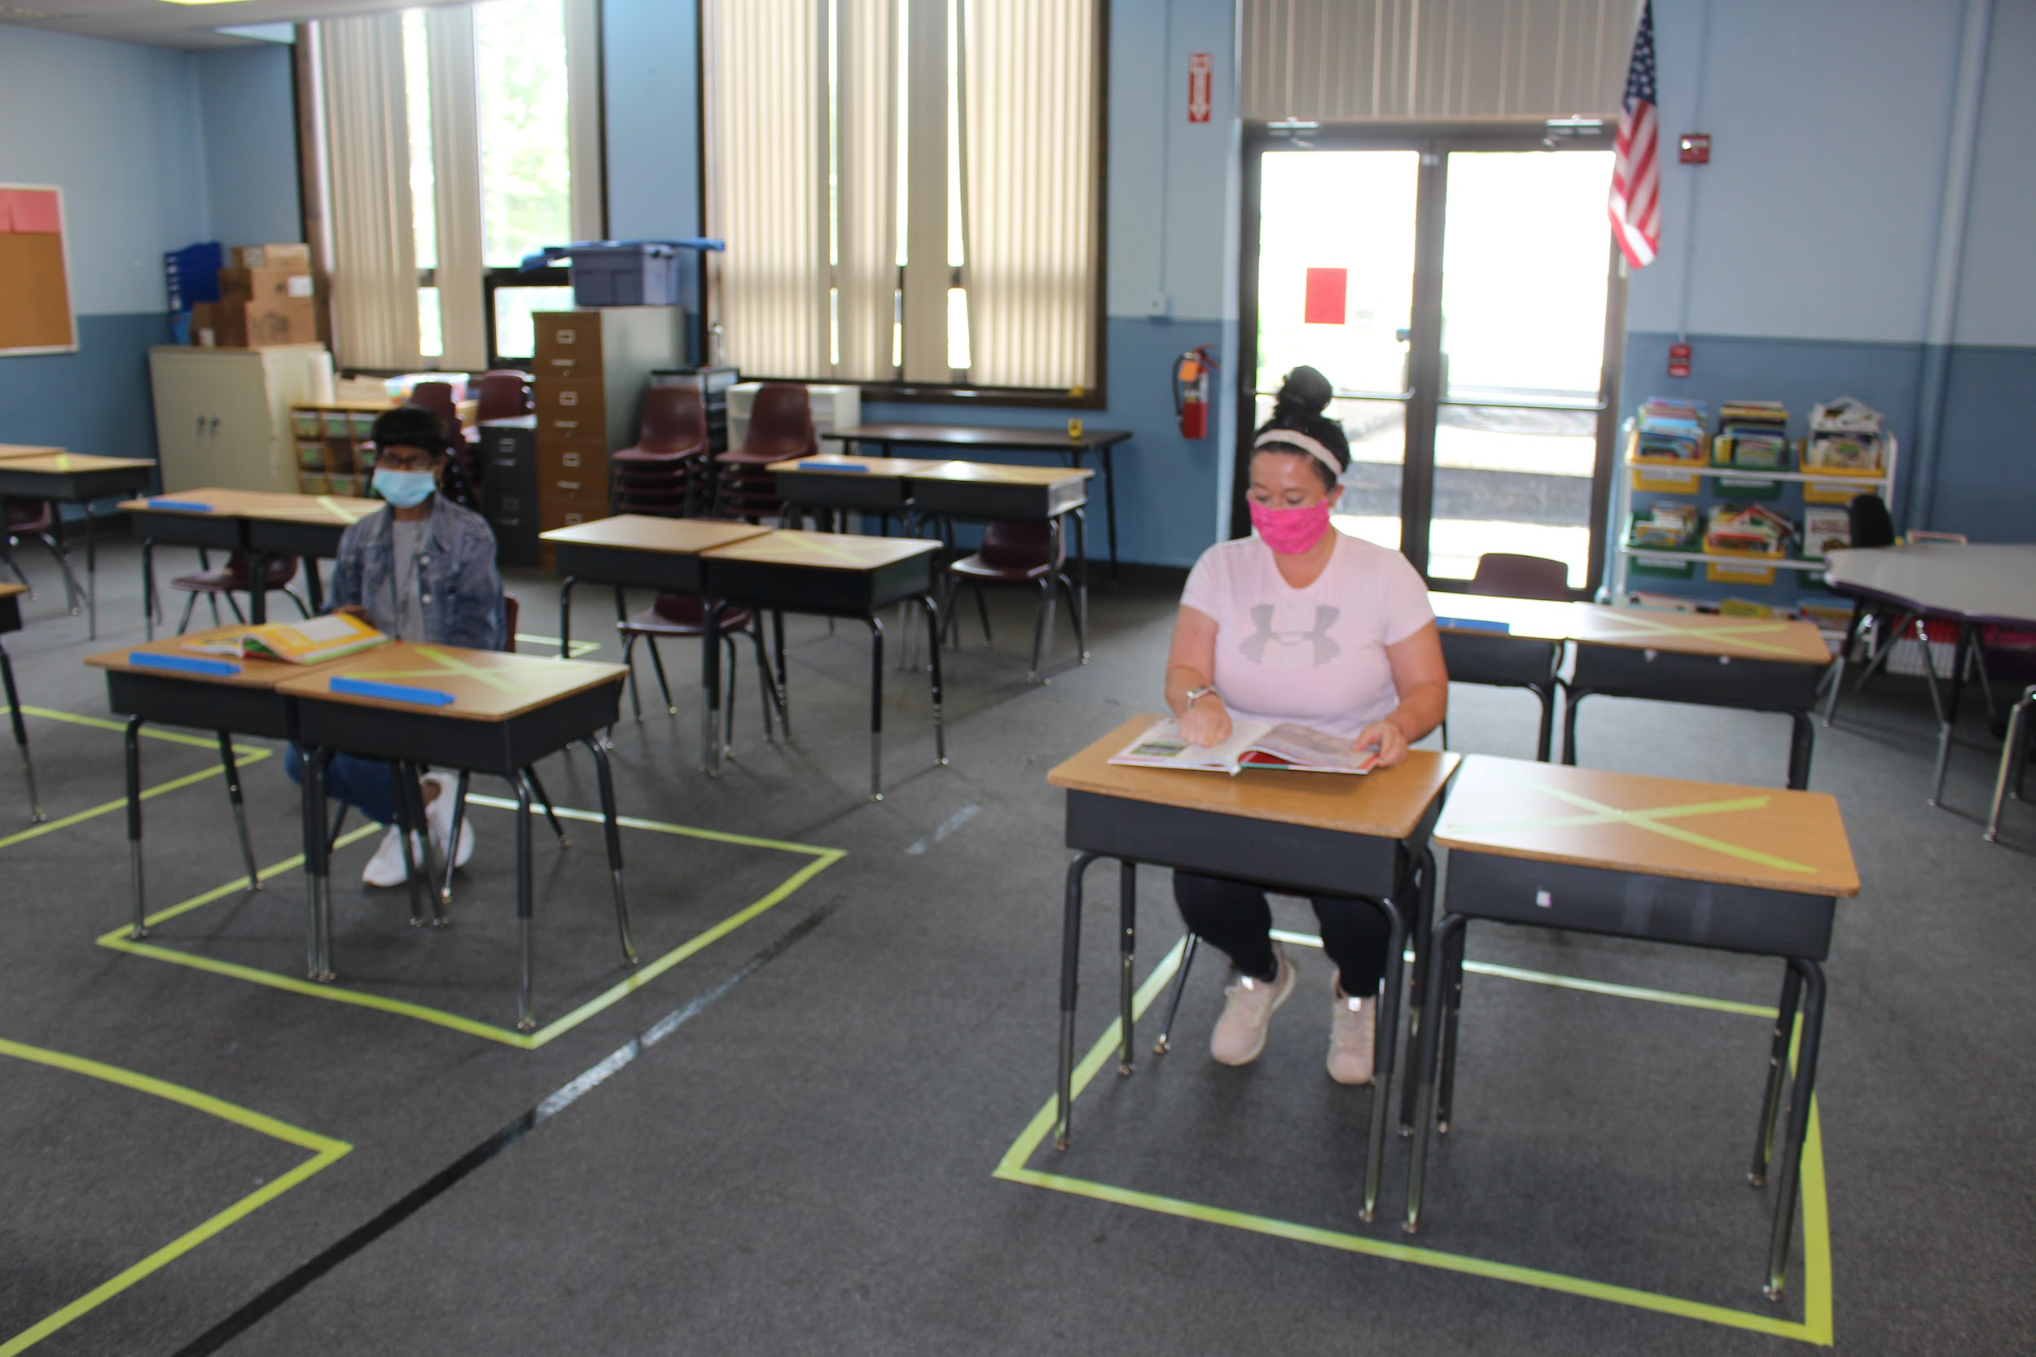
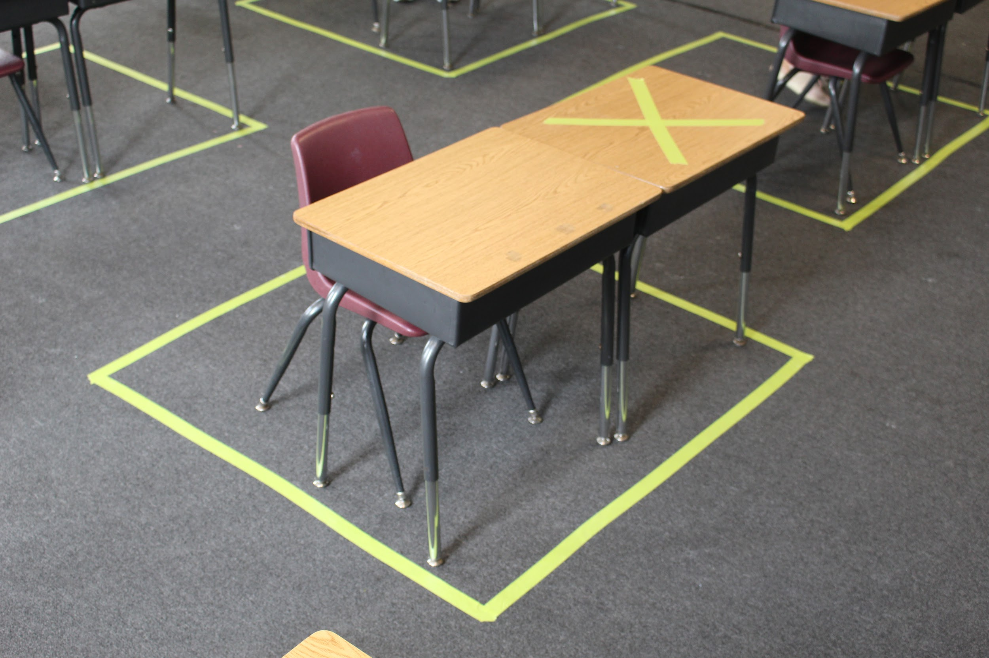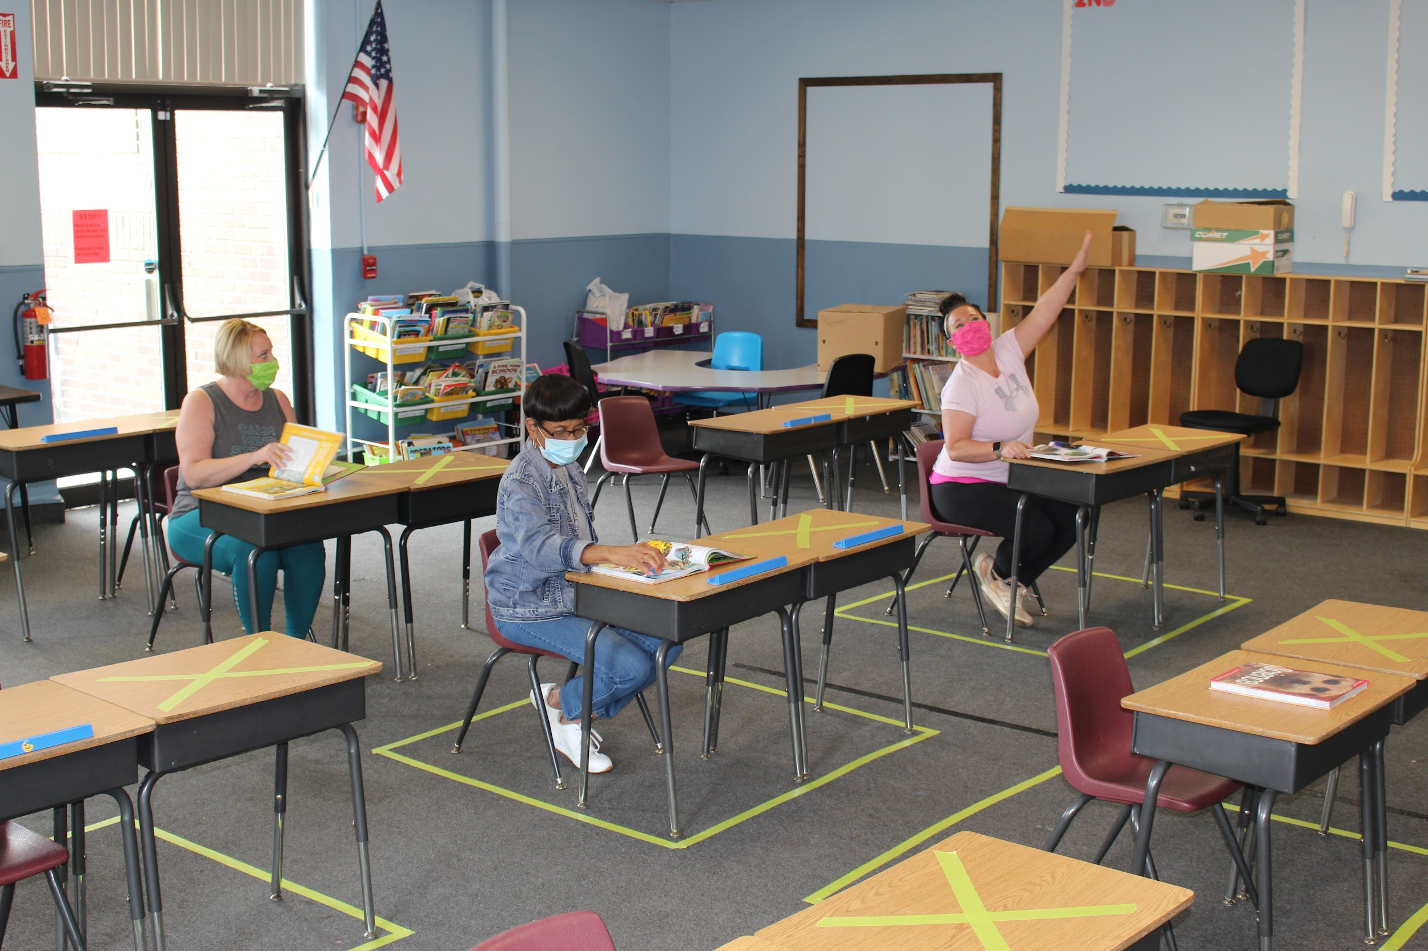
Physical & Social Distancing Guidelines:

- Keeping distance of six feet or more apart between people adds another layer of prevention against COVID-19.
- Six feet spacing will be included in classrooms, hallways, restrooms, cafeteria, and drop-off/pick-up locations.
- Students will not be permitted to share supplies, materials, and spaces (lockers, cubbies, etc.)
- Teachers will switch between classrooms instead of having students switch to minimize contact in multiple spaces
- There will be visual signs placed frequently throughout the school to help encourage students and staff to keep distance.
- Plexiglass and other partitions will be used between student and teacher’s desks to help minimize spread
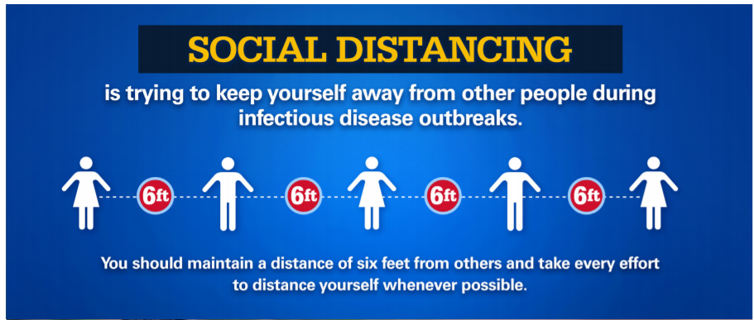

Daily Health Screenings:
COVID-19 can cause mild or asymptomatic infections, particularly in younger persons which poses challenges for preventative health screening. There are several benefits of active and passive health screenings before entering the classroom:
- Temperature monitoring can be done rapidly to immediately limit exposure to other students if a peer has an elevated fever
- A symptomatic student’s parents/guardians can make informed decisions to seek immediate care from a healthcare provider
- Information from a health questionnaire of symptomatic persons living in the same household can be helpful to limit transmission by requesting that students remain at home if someone in their immediate household is symptomatic and may be potentially infectious

Assessing for Covid-19 symptoms upon arrival: Students and staff will be sent home if:
- COVID-19 symptoms (described below) are observed
- a temperature above 100 degrees Fahrenheit
- any flu like-symptoms (fever, cough, shortness of breath) are observed
- In addition, each student and staff member will be asked the questions:
  - Does anyone in your household currently have any flu-like symptoms?
  - Has anyone in your household recently tested positive for COVID-19?

Before sending your child(ren) to school, check his/her temperature and observe for the following symptoms.

COVID-19 Symptoms Observed During the School Day:
If a student or staff member begins to show symptoms at school, or has a temperature above 100 degrees, they must immediately be separated from other students and staff and go home.

While students wait to be picked up, they will be monitored by a staff member wearing appropriate personal protective equipment (PPE) and maintain physical distance when possible. The space where an individual waits to go home will be an area that is not the nurse’s office or a highly traveled to location.

School personnel will refer individuals who display COVID-19 symptoms to an appropriate professional health care provider or a testing site. The Cuyahoga County Health Department will be contacted in the case of a positive or suspected COVID-19 case within the school building.

Students and staff who have suspected or confirmed COVID-19 cannot return to school until they meet CDC criteria for returning to work and/or school.

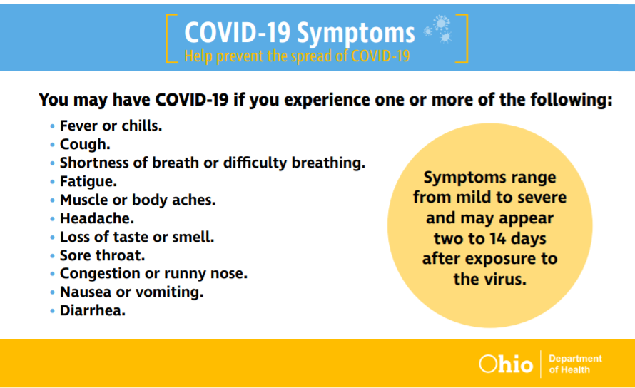

Updated Testing Information: Get Tested for COVID-19

Face Mask Policy
In times of elevated community spread, face coverings are critical to prevent the virus from person-to-person.

Face masks are required for all students and staff.

Training and Support:
- The school will provide staff and students with a face mask and face shield, however, staff and students may also provide their own mask.
- At minimum, facial coverings (masks) should be cloth/fabric and cover an individual’s nose, mouth, and chin.
- Appropriate training will be provided to all students and staff on the use of masks including taking them on and off
- The school will ensure that students and parents understand the importance of wearing masks, and the impact of not wearing masks.
- Teachers will incorporate and integrate proper mask protocols into their curriculum
- Wearing masks will become part of the school’s positive culture that embraces masks as a way of promoting community health, solidarity, dialogue, and forming/sharing identity.
- The school will recognize and address the social emotional impact of masks.
- Staff will shift focus of discipline to prioritize health and safety expectations over other minor dress code issues
- Free Personal Protective Equipment (PPE) for all staff and students, clear face shields or clear masks for those who need to be seen for educational purposes (speech, communication)
- The school will collect used masks at the end of the day and provide clean and/or new masks upon arrival.
- School nurses or staff who care for individuals with symptoms must use appropriate personal protective equipment (PPE), provided by the school, in accordance with OSHA standards.

Washington Park Community School will provide written justification to local health officials, upon request, explaining why a staff member is not required to wear a facial covering in the school.

Face Shields:

- Wraps around the face and extends below the chin. These will be provided for all students and staff.
- This can be considered as an alternative; where cloth face coverings would hinder the learning process and used in situations that impact learning and/or communication

The CDC offers information on cloth face coverings that recommends:

- Face masks should cover both the mouth and nose to maximize effectiveness.

- Face coverings should not be worn on children younger than 2 years of age

- Anyone who has trouble breathing or is unconscious, or anyone who is unstable to remove the face covering without assistance.

- Those at higher risk for COVID-19, those over 65 years of age, individuals who live in a nursing home or long-term care facility, or who have an underlying medical condition including serious heart conditions, severe obesity, diabetes, chronic kidney disease undergoing dialysis, liver disease or are immunocompromised should especially consider wearing a mask.

Additional guidance on face coverings can be found on www.coronavirus.ohio.gov

Teaching Students Health and Safety Practices:

Expected health practices require new learned behaviors by students. Teachers will provide age-appropriate instruction regarding: handwashing, physical distancing, appropriate use of face masks, cough and sneeze etiquette, and the importance of staying home when sick or displaying symptoms. Appropriate behavior expectations will be incorporated into Washington Park’s Positive Behavioral Interventions and Supports (PBIS) instruction.

Examples will include:

- Engaging students to be responsible for wiping down their own spaces (with time to chat, etc)
- Middle school students can create videos to teach younger students about new expectations
- Hold classes outside to promote ventilation.
- Project based learning
- Integrate health into learning: a lesson about the history of sanitation practices at the start of the year; Stories from 1918 Influenza in English class; Statistics about COVID in math class
- Engage students in the process of re-opening, new rules, new routines etc.
- Harness student choice and voice to promote buy-in and fidelity.
- Class jobs? Everyone hand washes, someone desk washes, someone does other jobs to ensure sanitation in the classroom.
- An Opportunity for life and home skills to become more integrated into the curriculum
- Making face masks a positive experience: Children and Cloth Face Coverings (Masks) - COVID-19 Checklist

Quarantine Policy:

- Individuals diagnosed or exposed to COVID-19 should notify the school if they have been exposed to COVID-19, or if they, or any members of their households, have been diagnosed with COVID-19. This includes students, staff, families, and caregivers.
- The school needs notification of any individual that is quarantined by a doctor, hospital, or health organization.
- Personnel and students with known exposure to someone diagnosed must self quarantine at home for 14 days.
- Students who are absent for a significant time period will be provided with online instruction to continue learning.
- Personnel and students diagnosed with COVID-19 must meet conditions prescribed by the Ohio Department of Health, Cuyahoga Department of Health, and the Cleveland Department of Health prior to returning to school.
- These conditions may change frequently, and Washington Park Community School will maintain frequent communication with the Cuyahoga County Health Department and the Cleveland Health Department regarding these guidelines.

Addressing Potential Flare-Ups:
Additional measures will be implemented in the event there is a “flare-up” of COVID-19 cases as determined by the Ohio Department of Health, the Cuyahoga Department of Health, and/or the Cleveland Department of Health. Remote (online) learning will always be an alternative to face-to-face learning as circumstances arise.

Option 2: Learning Online at Home (Remote Learning)
For those parents who choose learning at home, or remote learning, will be provided with the following for their child(ren) in kindergarten to 8th grades:
- Google Chromebook laptop and charger
- Internet accessibility
- Materials, resources, and supplies that will aid in the learning process (pencils, crayons, glue sticks, pens, workbooks, folders, textbooks, etc.)
- A username and password associated with school’s domain (wpcsoh.org) to access the learning platform
- Options for training and support for families and students on remote learning successes

Student Expectations for Online Learning:
- Log-in at required times and follow the school’s attendance policy
- Have all learning materials readily accessible and prepared for learning
- Remain in a learning environment at home that is free from distractions, and quiet (parents should consider setting up a home learning space that is similar to the school setting)
- Students must wear appropriate clothing during live instruction
- The laptop or computer used for learning must be charged and powered on during all live instruction
- Video and microphone features must be on at all times during live instruction
- Work must be completed and turned in on time
  - Kindergarten and grade 1 students will submit completed work through the Seesaw platform
  - Grades 2-8 will submit completed work though Google Classroom
- Students must communicate with teachers and students appropriately and timely
- Students must sit in an upright position (as if they are at a desk) during live instruction- no background noises that will disrupt the learning of themselves and others
- Students must follow all prompts and directions from the teacher and use the tools and features required to appropriately gain instruction
- Students must remain online for the entirety of the live instruction (in the event a student is late, leaves early, or does not log on will be counted against the school’s attendance policy)
Parents and/or guardians must immediately notify the school of any technical difficulties, problems with technology, and/or following online learning expectations.
If the above student expectations are not being followed, action steps will be taken:
- Parents and/or guardians will be contacted by the child’s classroom teacher to determine the root cause of problem areas. Together, the teacher and parent will discuss solutions to fix the problem(s).
- If student expectations continue to become problematic, a phone call and/or required meeting online with parents from administration will take place to determine solutions and other possible strategies.
- A third occurrence of disregard to student expectations may result in the option of continuing learning face-to-face at the school, or removal from the online program completely.
Parent Communication and Engagement:
- For most up-to-date information on school decisions and events, parents are strongly encouraged to sign-up and utilize Class Dojo (free app and web-based platform) School leaders and teachers will utilize Class Dojo for quick and efficient communication to parents and students

- Parents who opt in learning option 2 (online learning) are highly recommended to have a Gmail account (which is free). This will allow parents to monitor student learning, feedback from teachers, and progress made throughout the learning process.

- Parents are encouraged to contact the school by phone or email when questions, concerns, and/or issues arise during the 2020-2021 school year

- Parents are required to contact the office if your child will be absent from school in both online and face-to-face attendance

- Parents and/or guardians must be readily available in a timely manner to pick up his/her child(ren) at the close of the school day.

- In the event COVID-19 symptoms are observed and/or a student has a fever of 100 degrees or higher is evident, parents must be available to pick up his/her child and will be notified when he/she may return to school.

- Parents and/or guardians must address student concerns with teachers and school leaders that arise during student learning

- In the event that a student fails to follow school’s guidelines, protocols, and procedures, parents and/or guardians will be notified to pick up their child(ren) immediately. If repeated lack of compliance is observed, school leaders will recommend online learning as an alternative to keep other staff and students safe.

- Parents and guardians are encouraged to participate in online meeting opportunities and/or events offered by the school that will improve children’s learning and achievement.

Social Emotional Support for Students and Staff:
- Staff and students will engage and help to support social-emotional needs
- All learning environments (regardless of in school or at home options) will demonstrate emotionally and physically safe environments
- This includes:
  - Supportive teacher/student relationships
  - Minimal transitions throughout the day
  - Every student will have at least 1 caring adult that will check on him/her daily
  - Staff and students will be provided opportunities to practice their social emotional competencies (Example, reflect on the impact of the pandemic on themselves and the community)
- Use data as an opportunity to deepen relationships to continuously support for students, family, and staff

Educator Evaluation Systems:

- Teachers will be evaluated using OTES 2.0 for the 2020-2021 school year
- Evaluators will not include the “Evidence of Student Learning” component on the teacher performance evaluation rubric for OTES 2.0 during the 2020-2021 school year
- Teachers will receive training on implementation of OTES 2.0
- House Bill 197 and House Bill 164 will impact teacher evaluation cycles for the 2020-2021 school year. For more information: COVID-19 Impact on Ohio Teacher Evaluation System 2.0 Cycles

Third Grade Learning Guarantee:

- Under Section 18 of House Bill 164 of the 133rd General Assembly, the school will not retain a student in the third grade who does not meet the promotion score of 683 on the Ohio’s State Test for grade 3 English Language Arts if the student’s principal and reading teacher agree that other evaluations of the student's skills in reading demonstrate the student is academically prepared to be promoted to the fourth grade.
- This provision applies to students who are in third grade for the 2020-2021 school year and would be enrolling in the fourth grade for the 2021-2022 school year, unless retained.
- The promotion score of 683 established as the basis for promotion for third grade students completing the 2019-2020 school year and who will be in fourth grade (unless retained) at the beginning of the 2020-2021 school year, will remain the same for third grade students completing the 2020-2021 school year and who will be in fourth grade (unless retained) at the beginning the 2021-2022 school year.

Evaluations of Student Reading Skills to Determine Promotion in 2020-2021:

- Washington Park Community School will use NWEA MAP assessments in English Language Arts and Mathematics to determine if a student is academically prepared for the next grade level.
- In addition, the principal and reading teacher will use other evidence when determining if a student shall be promoted and/or meeting the requirements of the Third Grade Reading Guarantee
- Evidence collected and progress made during the school year and/or summer may be used, or
- Recommendation(s) based on evidence collected that documents student performance in reading, including as part of a documented reading portfolio from a student’s intervention specialist, Individualized Education Program (IEP) team, teachers of English to speakers of other languages (TESOL) specialist, English as a second language teacher or support service provider.

During the 2020-2021 academic year, Washington Park Community School will maintain documentation of decisions made regarding each third grade student’s promotion due to other evaluations of the student's skills in reading demonstrating the student is academically prepared for the fourth grade. Schools and districts will not be required to share documentation with the Ohio Department of Education, but a consistent documentation process will be helpful for record keeping and to ensure decisions made are as fair and consistent as possible.

Teacher Qualifications:
Under newly enacted legislation (Section 13(B) of HB 164 of the 133rd General Assembly), the Third Grade Reading Guarantee teacher qualification requirements to teach third grade students with reading improvement and monitoring plans (RIMPs) and retained third grade students have been suspended for the 2020-2021 school year.

Any teacher serving a student on a Reading Improvement Plan (RIMP) who does not meet the requirements should collaborate with a teacher who does meet the requirements to ensure high-quality interventions are being delivered. Please see pages 17-19 of the Third Grade Reading Guarantee guidance manual for a full list of the teacher qualifications.

THANK YOU FOR CHOOSING WASHINGTON PARK COMMUNITY SCHOOL!

WASHINGTON PARK COMMUNITY SCHOOL

ACKNOWLEDGEMENT OF STUDENT/PARENT HANDBOOK

Dear Parent/Guardian:

Please sign below to indicate that you have received and read a copy of our Parent Student Handbook and return this acknowledgement to your child’s classroom teacher.

Please review all information with your child(ren). Please list all student name(s) on this sheet.

I have received a copy of the 2020-2021 Student/Parent Handbook from Washington Park Community School.

___________________________ _________________________
Student’s Name and Grade Student’s Name and Grade

_________________________ __________________________
Student’s Name and Grade Student’s Name and Grade

______________________________________
Parent/Guardian Name (please print)

______________________________________
Parent/Guardian’s Signature

_______________________________
Date

"Firearm" includes any pistol, revolver, rifle, shotgun, or other device designed to or that may readily be converted to expel a projectile through a barrel by the action of an explosive. "Knife" includes any razor, shiv, or other sharp implement with a cutting blade and also includes any implement redesigned, filed down, or altered by the student or another for use as a knife, capable of causing bodily harm. "Weapon" includes any device that is either designed by its manufacturer or redesigned or altered by the student or another for use as a weapon, including any device in a student's possession that the student intends to use for the infliction of permanent or temporary bodily harm.
"Parent" means the student's biological or adoptive parent, guardian, or custodian, as applicable.

